Introduction

Excited about becoming a trader?

Want to put your money to work?

Lets go over some essentials to stock market trading

Welcome

Some important notes to start (please read carefully)

* Getting Started
  + Set goals
    - This only works if you work yourself
  + Make sure to engage and practice each section multiple times
  + Take all quizzes
  + Your own experience is what will make you successful
  + Its important to grow and enhance your own trading abilities
  + Always review your work and test your understanding
  + Your progress is in your understanding of each concept
  + Trading is a brand new language for you. The more you practice, the more fluent you will become
* Manage your goals
  + You must have a clear goal in mind and the path you must take to get to that goal
  + Your goals have to be realistic
  + Your efforts are vital. Don’t worry about making money rather plan out your day in learning the material and testing the concepts given to you in a paper trading account
  + Continue to learn consistently

Trading psychology

Trading stocks is a great way to put your money to work. It is vital that you have the daily input of educating yourself in daily worldwide activities. It is important to look at worldwide market trends. Politics play a huge role in business so educating yourself daily to worldwide events is just as important.

Before staring

* It is critical to have a growing mindset. That is to say, you should learn from your errors. This also means there will be a lot of hurdles, and you'll have to keep learning because the industry is continually evolving.
* Consider each trade as a stepping stone in your trading career.
* It's critical to think in terms of win-win scenarios. Even if you lose money in a deal, you may learn from it and avoid losing money in the future. Every minute you trade, you're getting closer to your goal.
* Always have a rationale for entering a transaction or adopting a position. Never merely dabble since you will lose money if you don't have a purpose.
* Confirmation bias exists in the stock market and on the Internet, which means you can discover research that supports your viewpoint on almost any topic. You should read both sides and form your own opinion.

Figure out your trading style

Different types of trading

Day trader (will open and close their position within a day

Swing trader (will opens a position and hold for several days

Position trader (will open a position and hold for a few months

Omni trader (will open a position with maximum return. Time is not a constraint)

**How much capital is required to start?**

* Capital is not important. Your abilities in finding the trades are
* Always start with a paper account to test your abilities
* You can start an account with $1000 - $2000
  + Your goal would be to grow it to $5000
* You must build a high level of confidence and conformability in trading stocks
* Giving yourself validation and not hopeful thinking will make you a better trader
* Set a goal to grow your account each month by 5-10%
  + If you succeed your already beating inflation. HOORAY!!
* Professional traders have account over $25,000
  + This is to avoid the PDT
  + PDT (Pattern Day Trading)
    - The PDT designation imposes certain limits on subsequent trading, with the goal of discouraging investors from engaging in excessive trading.
    - Account with a balance of over $25,000 can void this rule
    - If your account falls below $25,000 you will be subjected to this rule

Common Mistakes

* Focusing on short-term gains rather than long-term gains. Because trading is a probability game, you must determine which approach works in the long run rather than becoming puzzled by a loss.
* Even with the best setups, you will always lose in some trades. You just raise the likelihood of winning by using smart techniques.
* Only a long-term test may determine whether a strategy is effective.
* With a short-term outlook, don't form negative behaviors. If you adopt a negative habit, short-term earnings can turn into long-term losses.
* Concentrate on the long term and what you can do on a daily basis to boost your long-term capability and profitability.
* Starting with paper money is the best place to start. You can only develop yourself and your strategies by training with a paper account.
* Getting caught up in the whims of the law. When something works once, you assume it will work again. These are just poor habits that you can pick up on the way.
* Failure to learn from your mistakes in the past. Try to remember how and why you took a certain action. Make an effort to hold yourself accountable.
* Be realistic and seek a middle ground.

**Practicing made easy**

* Start with a paper trading account
* Make your paper account profitable
* Give yourself the validation that you are trading correctly

**Understanding Cash or Margin**

* Margin account allows you to borrow money from your broker increasing you buying power
* This will increase your profit & risk
* Usually brokers will give you 50% margin (If you deposit $5000, your broker will lend you $5000. This will increasing your buying power to $10,000
* You must keep a set quantity of money in your account. If you fail to do so, the broker may issue a margin call. Margin call indicates that you must meet the conditions or your holdings will be closed.
* You must pay interest on margin based on your broker and the amount of money in your account.
* Because of interest rates, short-term margin positions are preferable because you have to pay more interest over time

Common account types

* There are two types of accounts. Margin and cash accounts are two different types of accounts. Settlement Periods are aided by the use of a margin account. Most US brokers have a T-2 (two-day) settlement time, which is when you get your money back after selling.
* If you have a small cash account, your capital will be locked for two days, which is not the case with a margin account.
* The PDT rule is not an issue with a Cash account, but it is an issue with a Margin account. The PDT rule states that if your account balance is less than $25,000, you can only make three day transactions every week. There are a few options for dealing with the PDT regulation.
* Shorting shares is possible with margin accounts, but not with cash accounts.
* Margin should not be used for really lengthy positions. For short-term positions, margin might be beneficial because it enhances your purchasing power.
* Margin should be treated as if it were your own money because it carries a higher risk.

**Getting around the PDT rule**

* If you have a margin account with a balance of less than $25,000, the PDT rule states that you can only execute three day transactions every week.
* You can use numerous brokers because PDT rules apply per broker.
* Convert to a cash account, but be aware of the T-2 settlement delay. I propose that you use this strategy as a beginner until you reach the PDT requirement level of 25k.

**List of popular brokers**

* Interactive Brokers (recommended)
* Webull
* TD Think or swim
* Not all brokers are available for Pakistan

**Setting up your indicators**

* We will be using
  + SMA (simple moving average)
    - Length 9
    - Colour blue
  + SMA (simple moving average)
    - Length 180
    - Colour red
  + Volume
  + RSI (relative strength index)
  + MACD (moving average convergence divergence)
* Make sure to set these settings to your charts

**Lets get started**

Understanding price action

Price action is the result of thousands of traders selling and purchasing stocks. It can assist us in identifying different trends, spotting patterns, and determining whether a company is under or overvalued. It also aids us in determining the likelihood of any desired outcome.

Price action can also assist us in determining a stock's risk vs. reward. This is one of the elements we consider when deciding whether or not to purchase a stock. It's crucial to remember that this isn't the only aspect we consider when making a decision.

Lets take a look at the risk reward of ticker symbol $BABA as a day trade

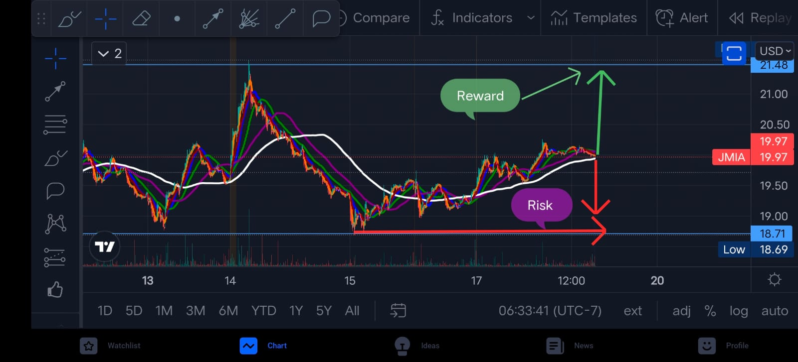

Our goal is to figure out what drives price movement. As traders, our job is to correlate price action and technical analysis with fundamentals to determine why this price action occurs. This will be discussed in greater detail later in the course.

**Lets break it down**

1. Price Action
   1. Breakdown opportunities
   2. Confirm good setups
   3. Find great execution points
2. Fundamentals
   1. Explain the price action

Using Candlestick charts

Candlestick charts, rather than line charts, provide more detailed information regarding price action that a conventional line chart cannot convey. Here is a explanation of green and red candlesticks taken.

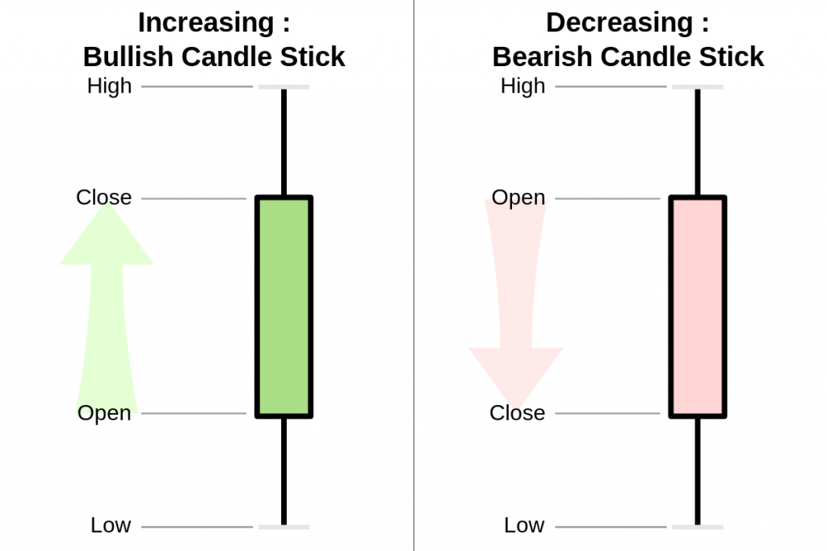

There are also wick candlesticks, which show the price opening and closing at the same price.

They are represented by a neutral candle

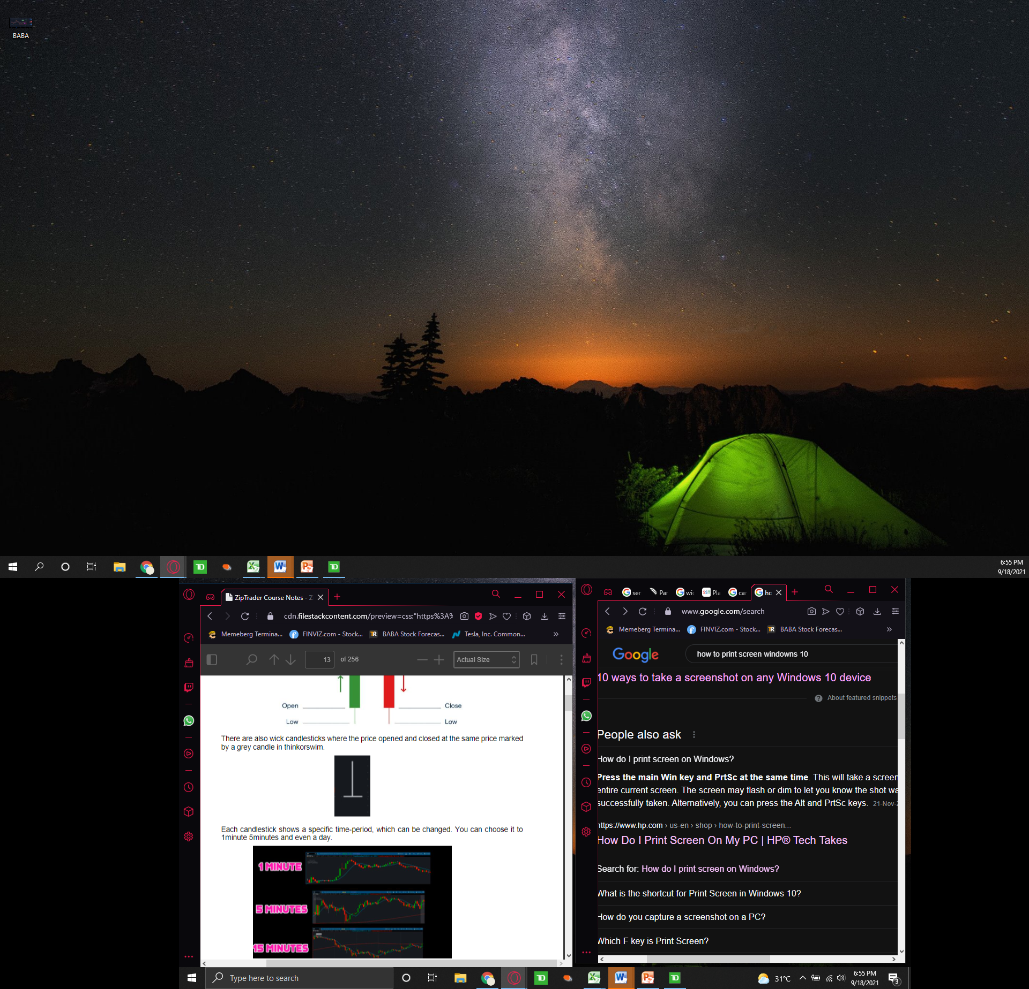

Each candlestick represents a different time period that can be modified. You may set it to 1 minute, 5 minutes, or even an entire day.

Lets take a look at ticker symbol $MSFT on the

1 minute chart

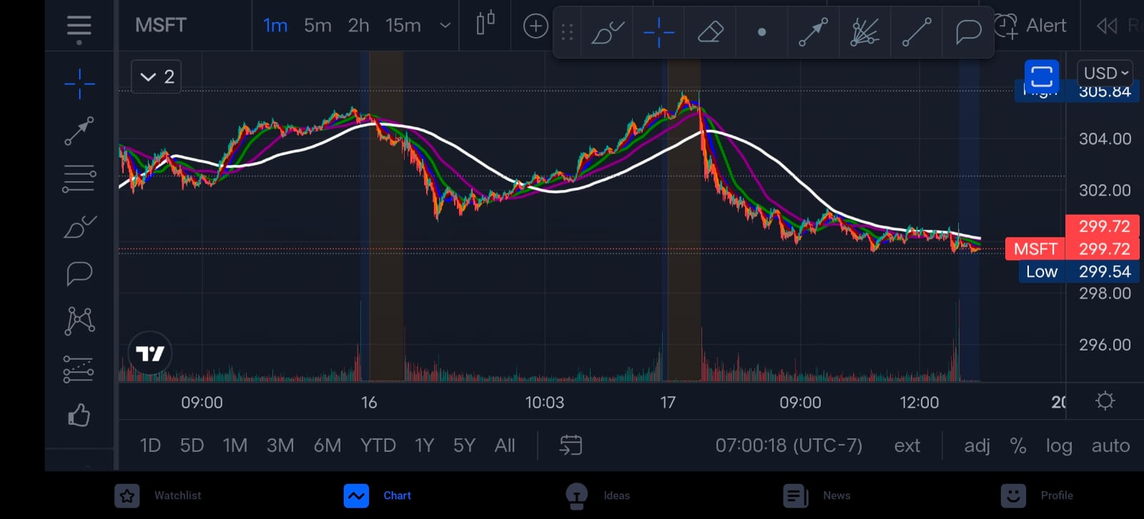

5 min chart

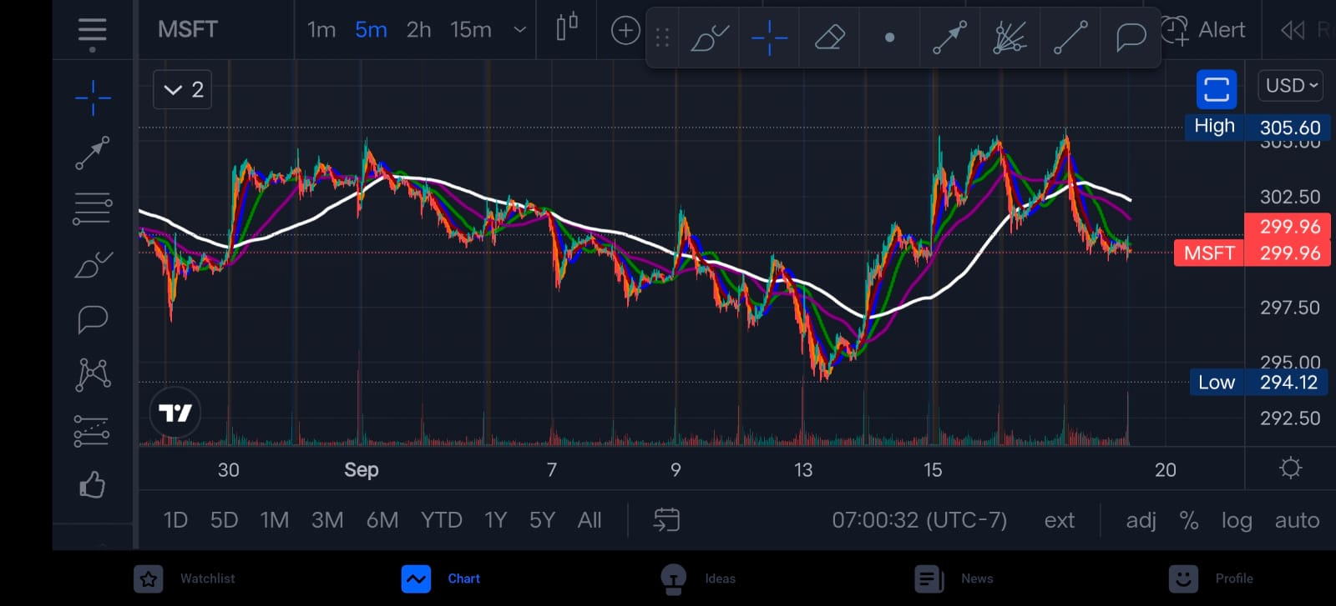

15 minute chart

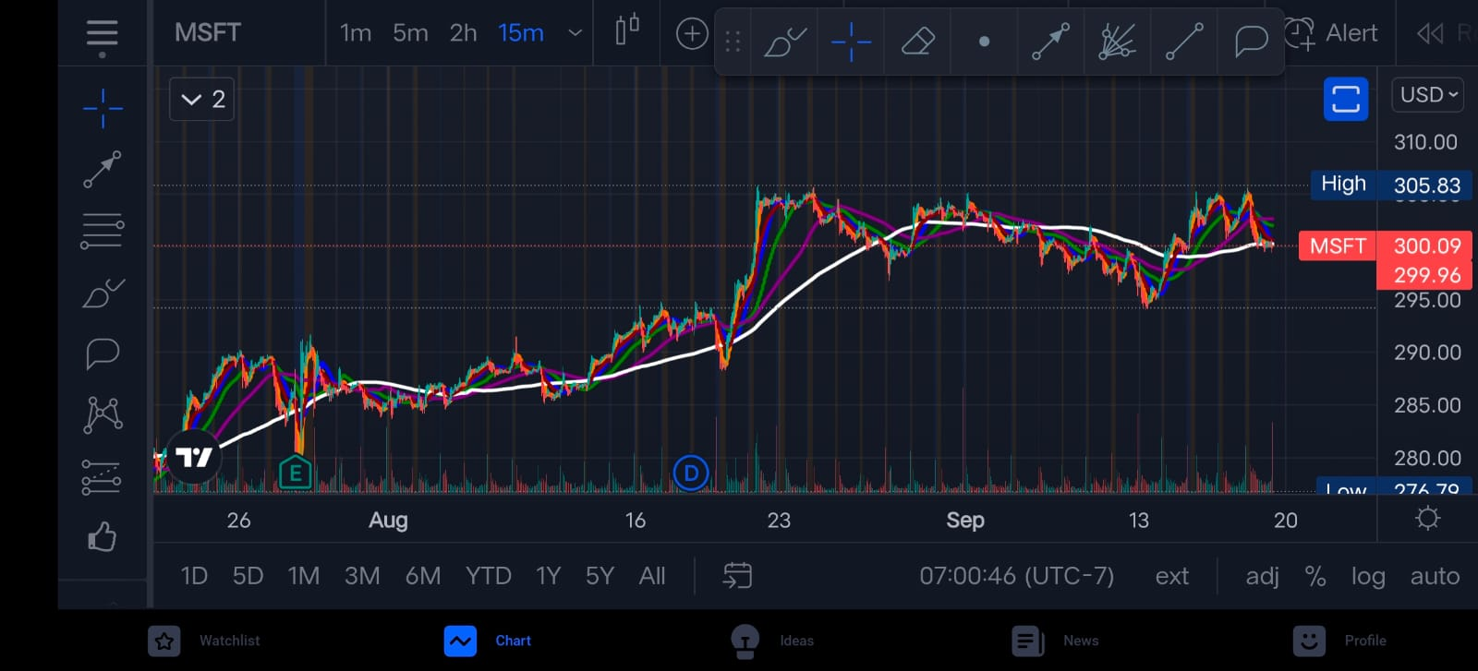

2 hour chart

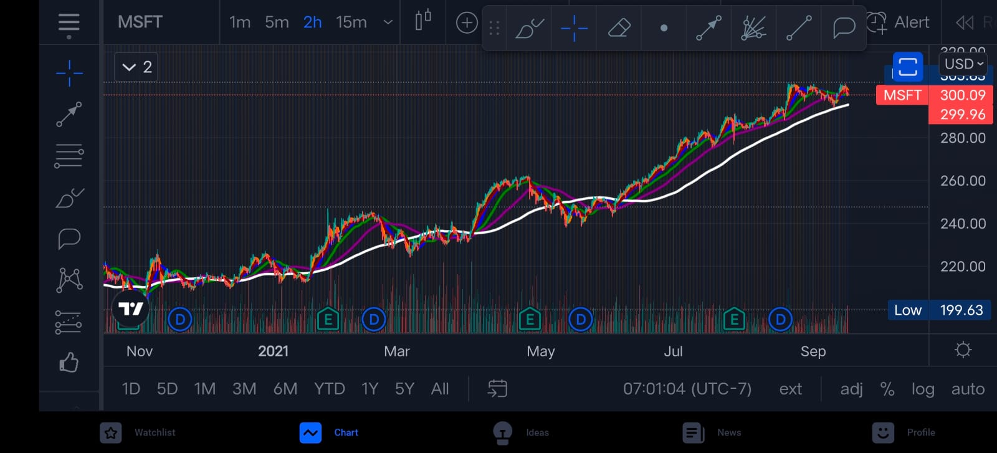

Each chart will give you different information to analyze. It is important to look at different variations of charts to get a fundamental analysis of short term and long term price action movement

**Identifying levels of support and resistance**

Lets take a look at ticker symbol $DIS

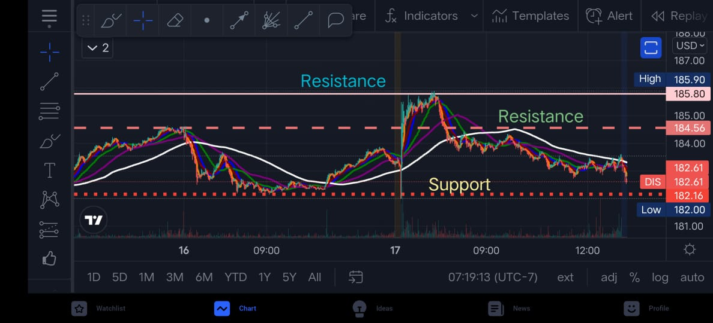

Price movements have varying degrees of strength and weakness. Support and resistance levels are what they're called. The price level at which the stock is unable to break below is known as support. The price level at which the stock is attempting to break above is known as resistance. These are depicted in the image.

* **As you can see a stock can have more than one resistance and support depending on the price action**

These levels can assist us in determining the possibility for upside vs. downside price action movement. When buying a stock, for example, it is preferable to be as close to the support level as feasible because this reduces our risk.

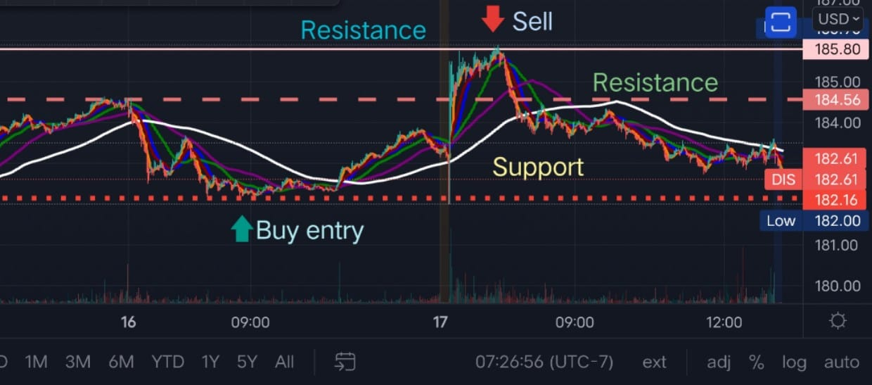

It doesn't imply we can't take a position near the resistance line; it's just one limiting aspect that reduces our chances of success. If a stock repeatedly hits a Support/Resistance level without breaking it, that level becomes more powerful.

Important: When a stock reaches a resistance level and breaks it, the new level becomes a support level, and vice versa. This can be seen in the chart below, where the stock broke the resistance level and became a support.

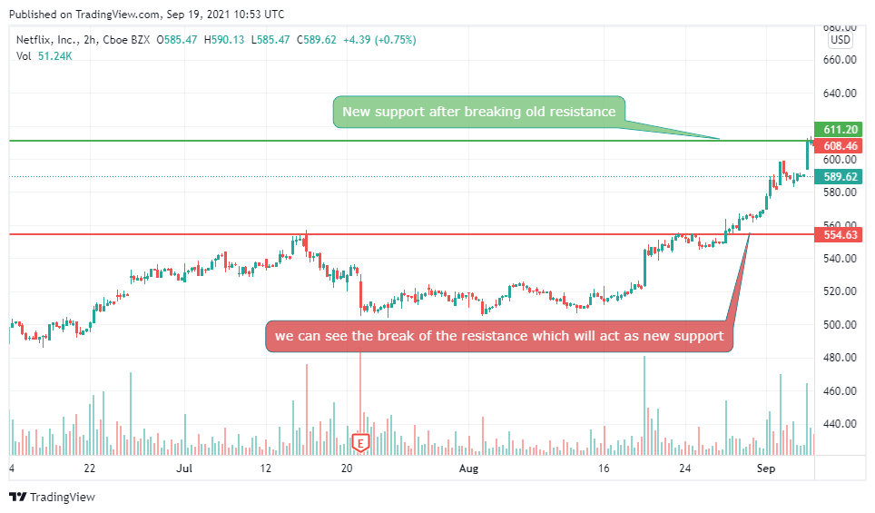

As indicated below, there are also down-trending and up-trending support and resistance levels (also known as channels). When a stock is continuously up-trending or down-trending, this occurs. The 75 percent rule is frequently used to these equities. In the case of equities that are down trending, this means that each high is 75 percent of the preceding one.

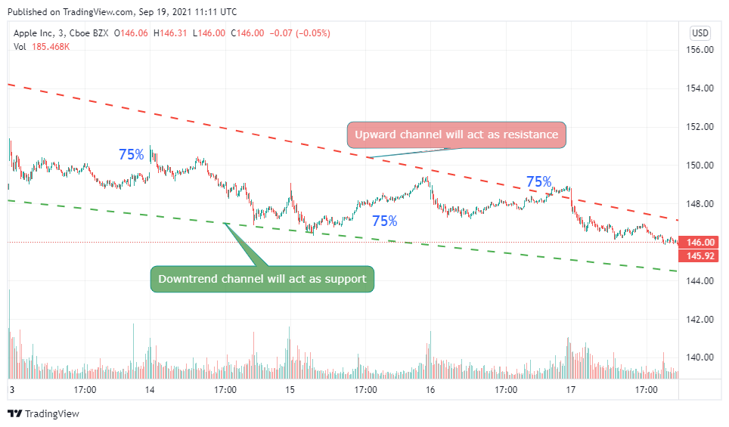

The task at hand is to determine which amount of Resistance/Support is appropriate for the position you intend to take. If you're a day trader, it's probably best to focus on intra-day support and resistance levels, but you should also consider the big picture to get a sense of how the stock is performing.

For example, if we wish to take an Intra-Day position, we can notice that we are trading near a short-term resistance level, which we can use to our advantage. However, when we look at the long-term chart, we can see that it is still a long way from its long-term support level, implying that the risk-to-reward ratio is high.

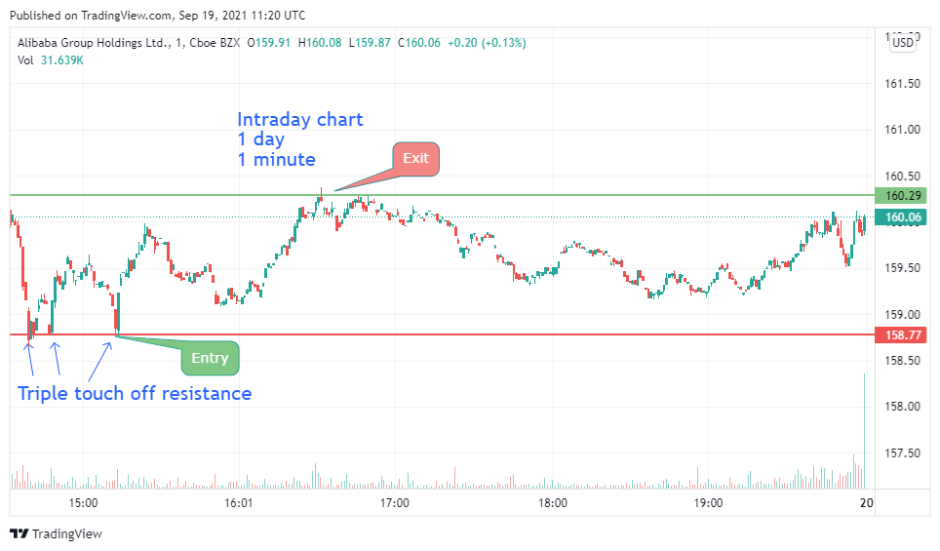

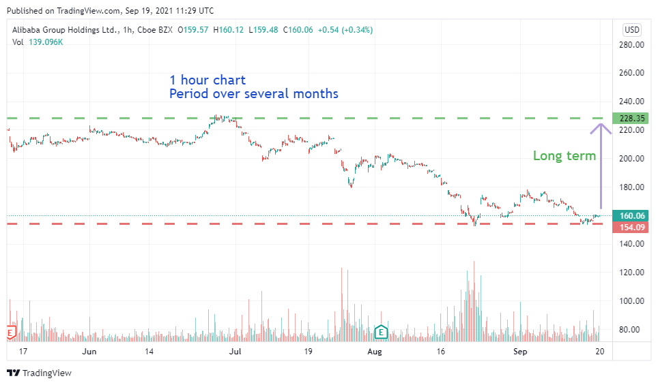

**Drawing effective support and resistance**

The most recent tested level for the time period relevant to your trade is considered as effective support and resistance level. This is the level of Support and Resistance that you are most concerned about.

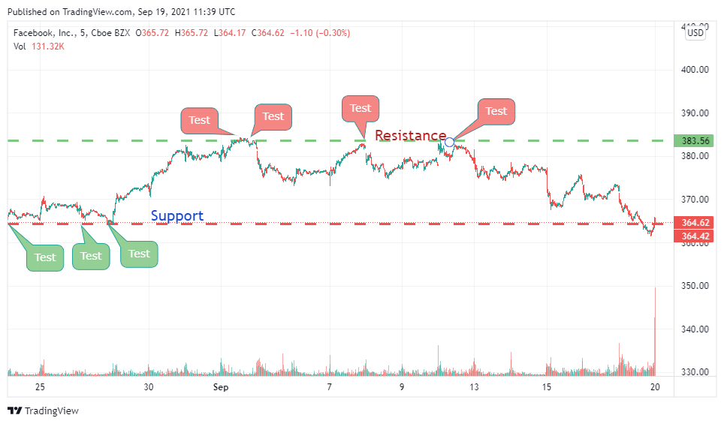

It makes more sense to define the short-term support and resistance levels as the Effective levels if you are adopting a short-term position. Long-term levels, on the other hand, are crucial for Context.

When a support or resistance level is struck several times, it only strengthens it.

**Let's look at a scenario where we wish to take a short-term stake at $SQ. The long-term and short-term levels are depicted in the diagrams below.**

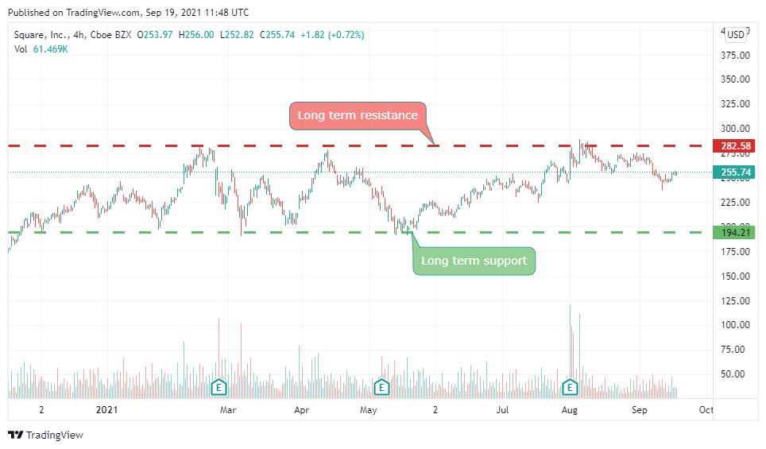

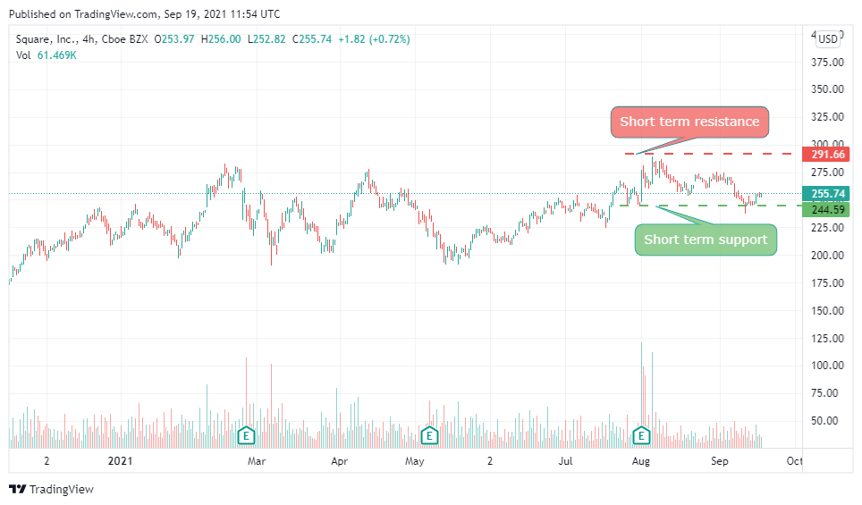

As you can see, the stock is near its short-term support level, which is the effective level in our situation; therefore it makes sense to take a position here. However, if you look at the long-term levels, you can see that we have a greater downward potential than an upward potential.

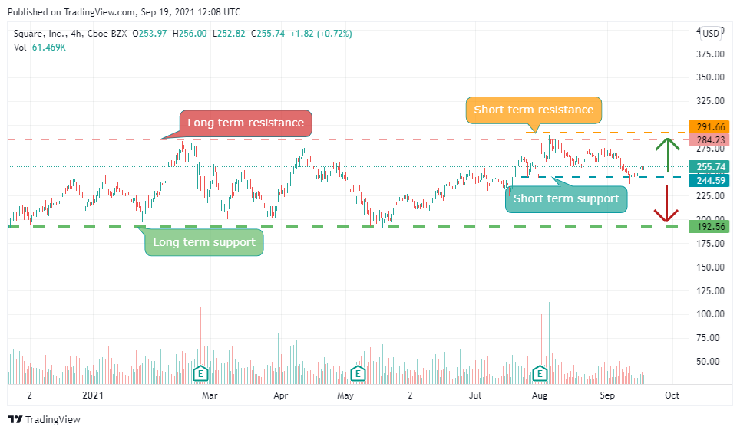

Despite the fact that these amounts of support are ineffective, they are crucial due to context. It's possible that this stock may continue to fall until it reaches its long-term support level. As a result, context is crucial.

**Let's look at an example where we want to take a short-term position in $LCID. The long-term and short-term levels are depicted in the diagrams below**.

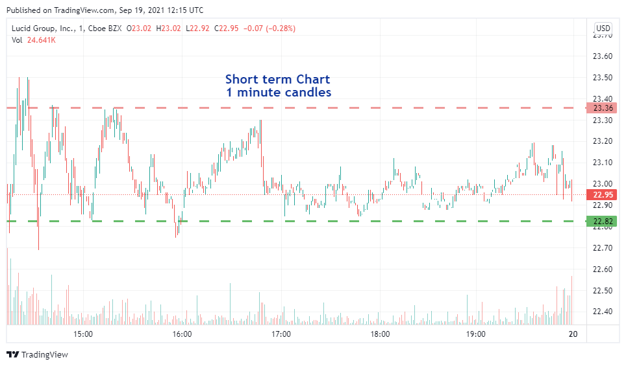

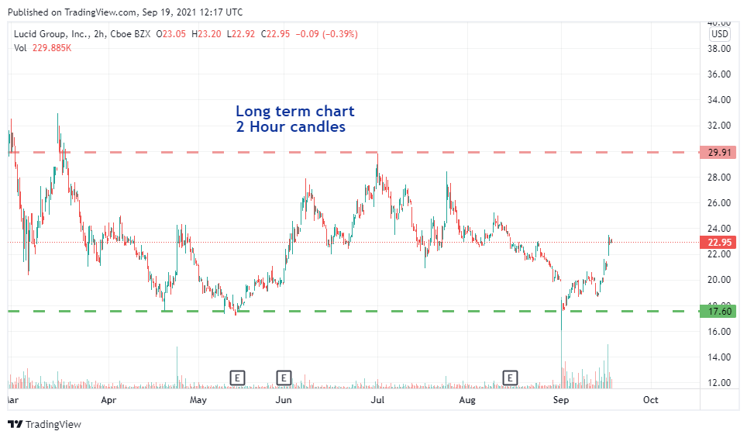

Pay close attention to the price bar to see the difference in context in both charts

We can see that, while there is less short-term potential because we are trading near the Resistance, there is more long-term potential. As a result, taking a position here only makes sense if we intend to maintain it for a long time. This is why it's crucial to understand the context.

**Let's look at $NIO as an example, where we want to see the long-term effective support and resistance levels.**

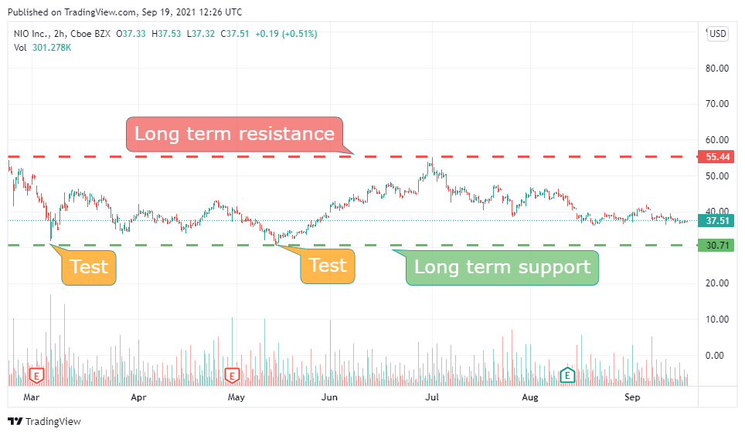

This support level was struck twice, as you can see in the chart above, making it a powerful support level. When we examine closely, though, we can see that there is another level that has been struck numerous times and is newer.

As a result, it becomes stronger, and we should concentrate on the Effective Support level. The illustration below depicts this.

Short term resistance, short term support, long term resistance, long term support.

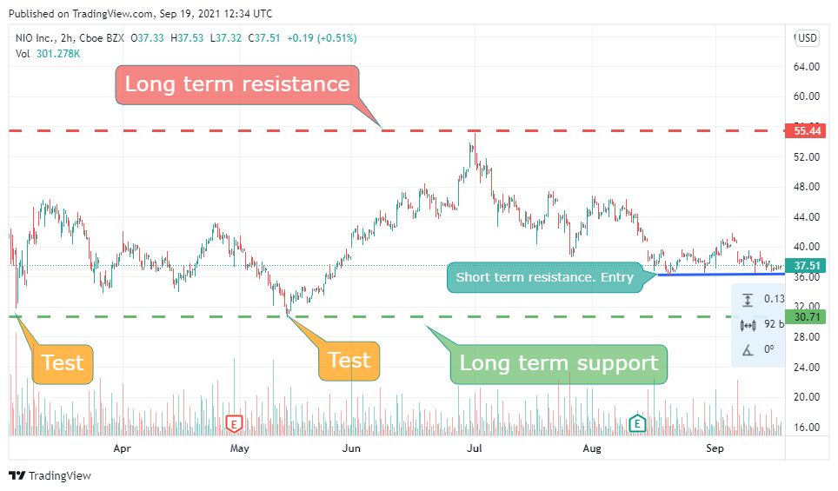

As a result, it is preferable to designate this as the Effective support level, although you may still choose the bottom level as a conservative level of support to reduce risk.

It makes more sense here to declare the more recently testing support line as the Effective support line.

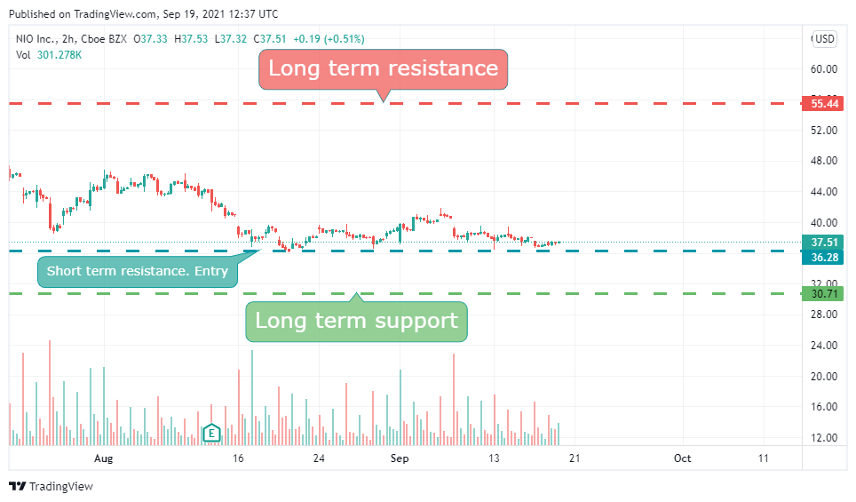

In general, newly measured values take precedence over previously tested ones.

**Additional rules**

When a support level is broken and the price falls below it, the level becomes a resistance level, as indicated in the diagram below. The stock fell below the Support level at this point. As a result, this Support level has now become a Resistance level.

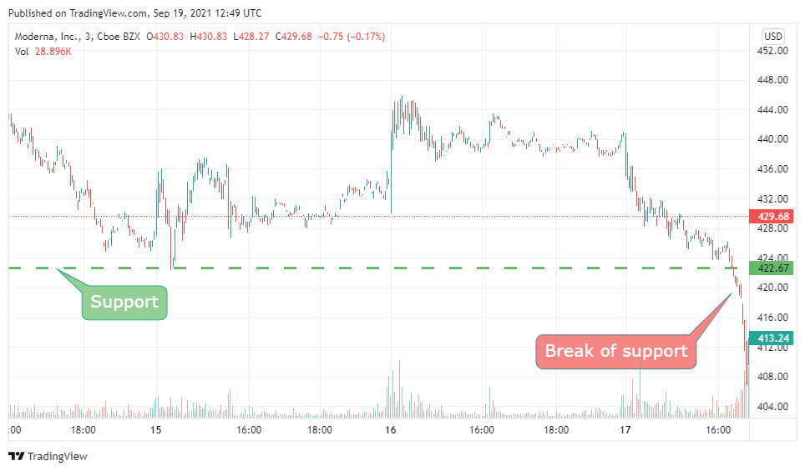

The opposite is also true like when a stock breaks a Resistance it becomes the new support as shown in the picture below

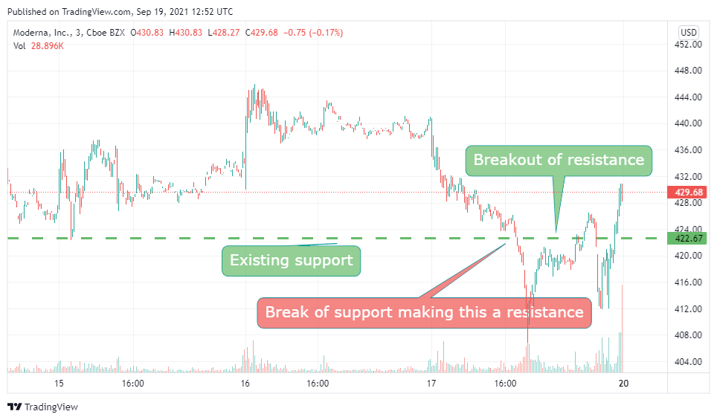

Because these new levels are so fresh in both cases, they can serve as effective support and resistance levels.

**Example 4: Using $NVDA as an example, we can now determine the Effective Support and Resistance levels. On the intra-day chart, we can see that $NVDA has broken through the prior resistance level, indicating that it has now become the new support level.**

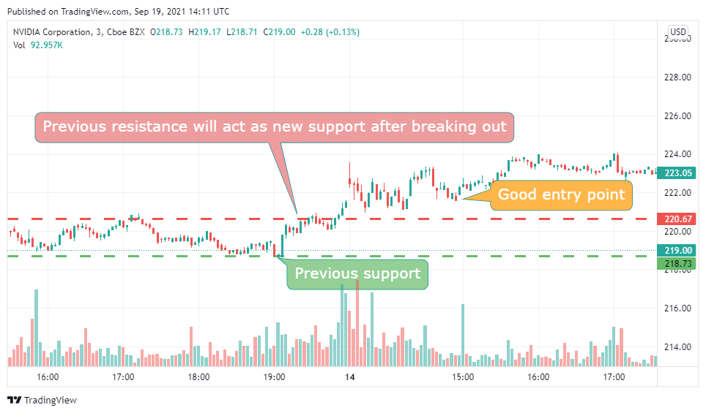

**As a result, the effective support and resistance levels are indicated in the diagram below.**

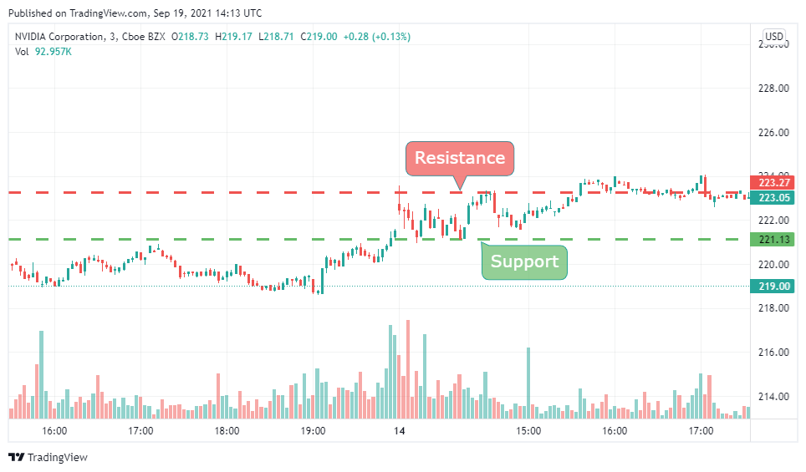

**However, you must observe the long-term levels for perspective, since they may impact the stock even in an intra-day position.**

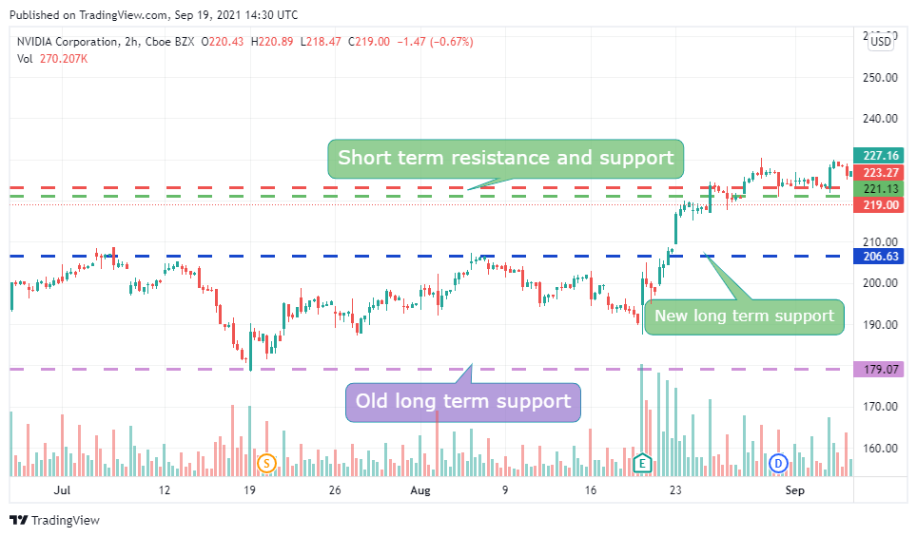

**Risk vs. Reward ratio**

The first thing to remember is that just because something has greater upward potential than downward potential does not imply it will move upwards. Likewise, the inverse is true. A stock's price fluctuation is influenced by a variety of variables. The route that a stock can drive on is simply the upward vs. downward potential. If it has more elevating elements than deprecating ones, the more road it has in the upward category, the more room it has to run upwards. If the ratio is larger, we are taking on more risk, and if it is lower, we are taking on more profit.

**Example1: Let’s take an example for $MSFT where we plan to take a Intra-day position at the entry point marked in the picture. We want to find the risk vs. reward ratio at that point.**

**We may compute the Risk vs. Reward ratio by marking the effective support and resistance levels, as illustrated below.**

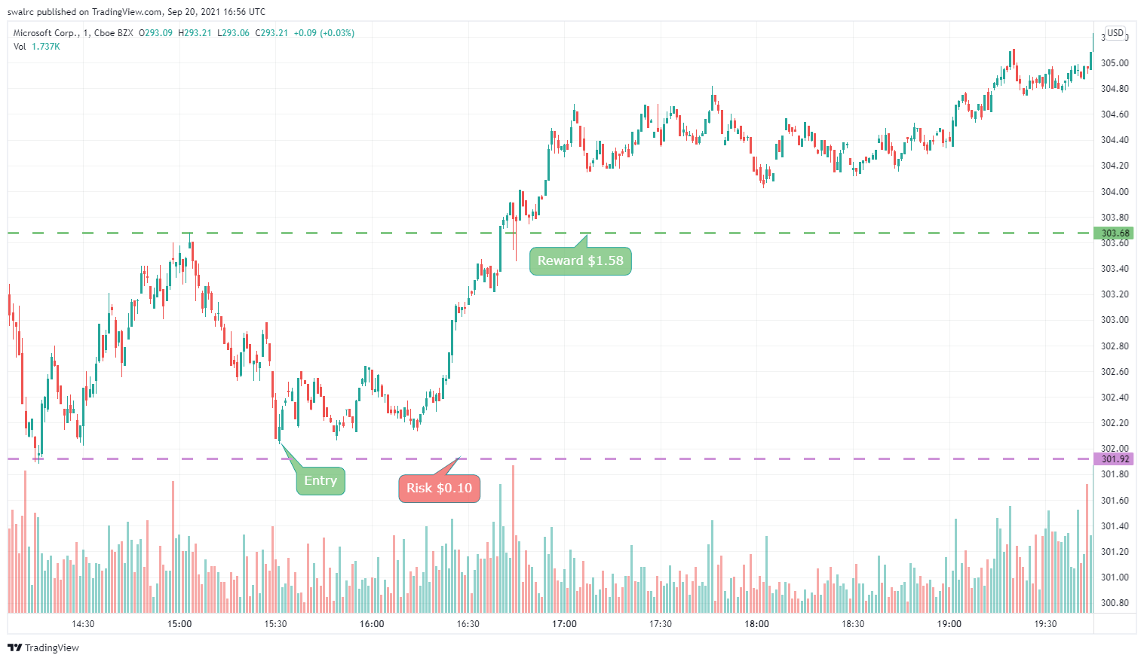

**Example 2: Let's have a look at another ticker symbol $AMZN case study. We are interested in working here for a few weeks. As a result, we must examine a chart that has data for longer than two weeks. This is when a 30-day chart is ideal.**

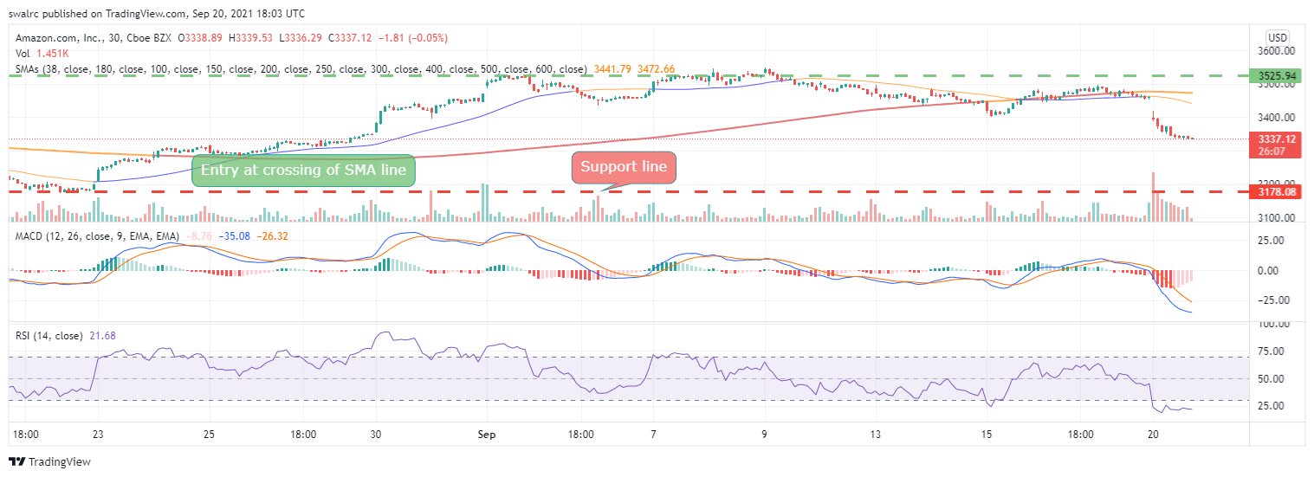

**We may compute the ratio as indicated above by drawing the effective support and resistance levels.**

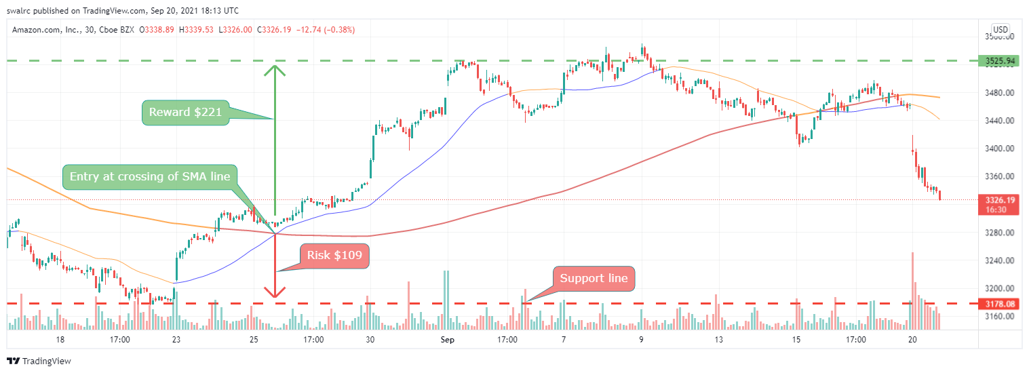

**As previously said, this is simply the path that price action can go if we receive any favorable news or trigger. This is something that will be explored later.**

**Example 3: Let's look at another example $LCID where we may apply for an intra-day position.**

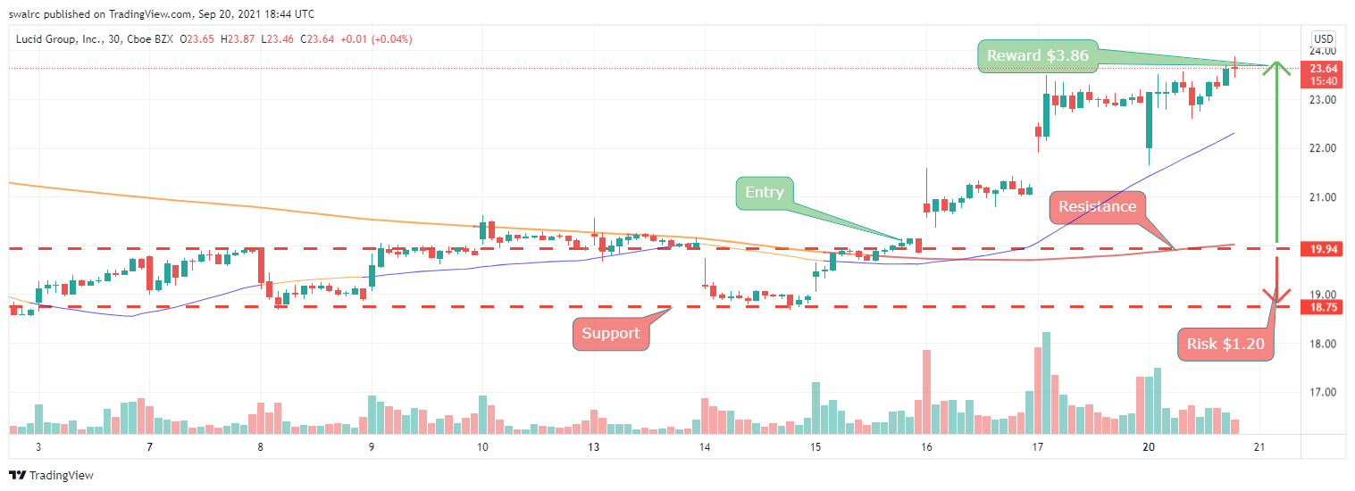

**We can see that the stock has upward potential of $3.86  This does not rule out the possibility of a loss if we take a position here, as the stock has since risen. It simply implies that the stock must break over the resistance level with momentum in order to be lucrative. As a result, taking a position here with this setup is a good idea.**

**Example 4: Let's look at another ticker $AMD. Where we can enter for a few months. That is why you should look at a long-term time chart, such as one that spans 180 days.**

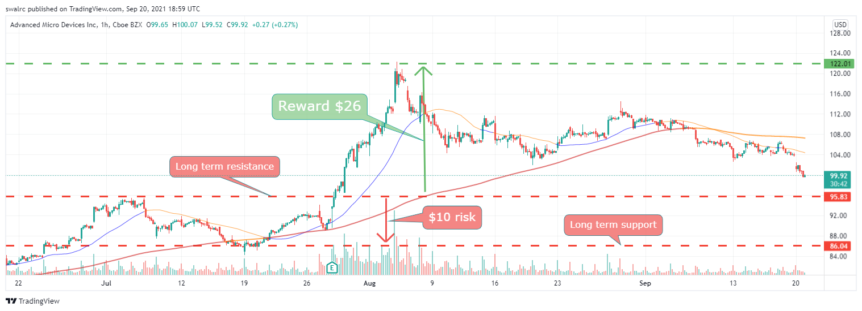

**This is what it looks like if we solely utilize long-term support and resistance levels. This demonstrates that we have some upward and downside possibilities.**

**However, if we look closely at the chart, we can see that the price has struck another support level twice. As a result, we should utilize this as our effective support level.**

**Important Points to remember:**

**The risk vs reward ratio, or the upward versus downward potential, is just the path that our price action can take. That indicates that if we have greater upward potential and the stock begins to go upward, there is more room for the stock to move higher. Please keep in mind that stocks frequently break these patterns, but in general, a pattern will likely to repeat itself over time. It's almost as if it's a self-fulfilling prophesy.**

**Important Points to Remember: Trend lines and channels tend to follow particular patterns; they can assist us in making trading decisions. Trend lines help us comprehend recurrent patterns by breaking them down into smaller chunks. When used in conjunction with other techniques, they can significantly improve our chances of success. Channels are only one component of a quality system.**

Volume and Float:

**A stock's volume “Total number of shares exchanged within any particular time period” is how volume is defined.**

You can see daily volume here as shown below for $FB

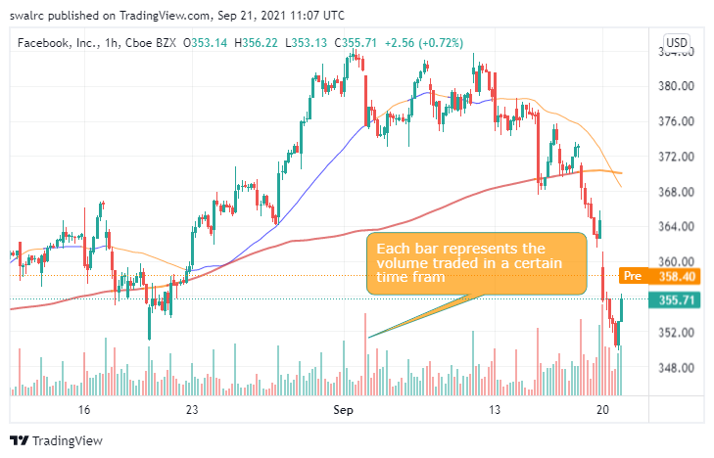

**Lets take a look at a stock where the volume is less $RKT**

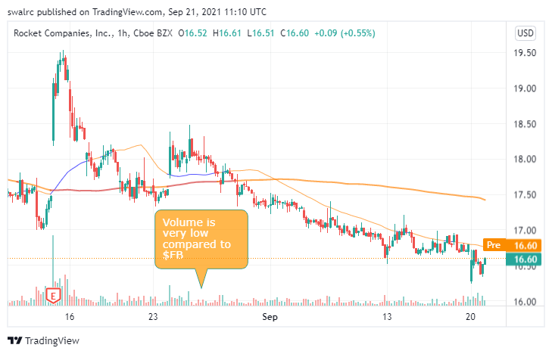

**The difficulty with low volume is that the stock hardly moves, and when it does, it moves randomly, as seen in the RKT example above. Furthermore, there is a danger that just purchasing or selling such stocks will alter the price. If you sell, it's possible that the stock price will drop and the execution would be sluggish since fewer people will be purchasing it.**

**A daily volume of 200,000 – 250,000 is suggested as a minimum.**

Take a look at $MRNA, for example. Even if the daily volume is over 200,000, the Intra-day chart shows that the majority of the trading takes place during the open and closure of the market hours.

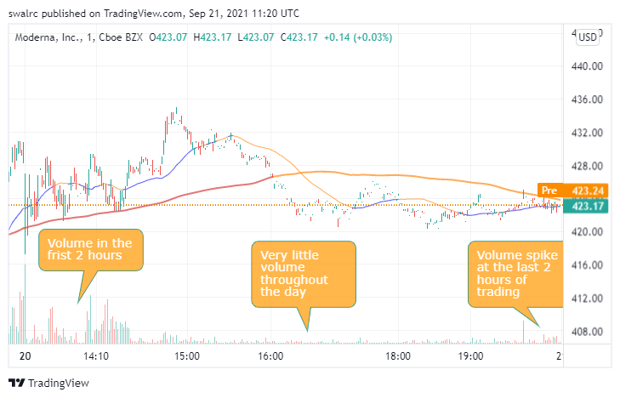

Depending on the position you want to take, this might be troublesome. The greater the volume, the less likely you are to run into this issue.

**Exceptions**

Stocks with low volume that see a jump in volume due to a news trigger such as FDA approval, earnings release, etc. During news catalyst days, stocks are more likely to see a spike in volume. This helps you to swiftly execute your positions.

Take a look at the data for $ACRX , which shows a jump in volume following FDA rejection.

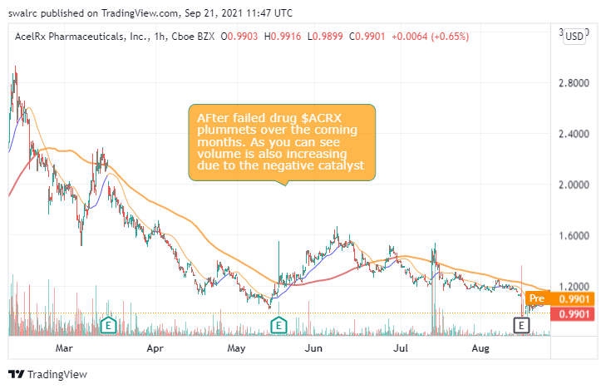

Volume is also used in other ways.

A stock with unusually high volume might be the result of a press release or some type of insider trading that we aren't aware of. You may take advantage of this by programming scanners to detect unexpected volume spikes. You may be able to uncover previously undiscovered prospects as a result of this.

An example of this is below with ticker symbol $GSKY where alleged insider trading was happening before the actual news catalyst

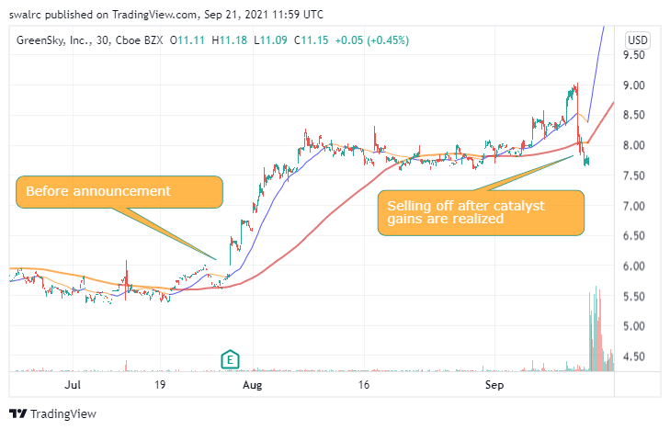

**Stocks Float**

**The “Total Number of Shares Tradable for Any Given Stock” is referred to as float. You can tell whether a chart has a low float by looking at it. Take a look at the graphs below, for example. There aren't any candlesticks to be seen.**

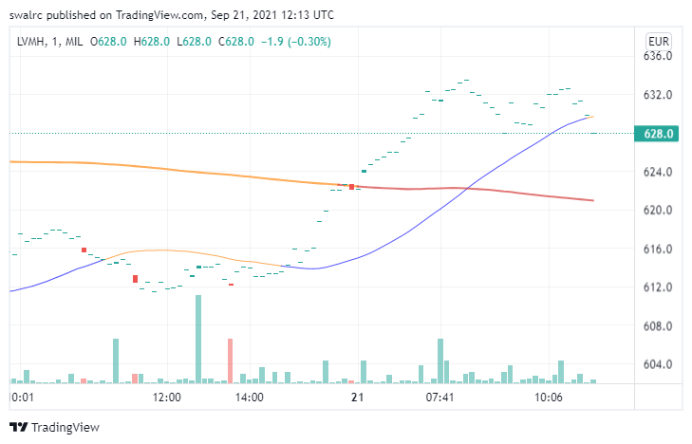

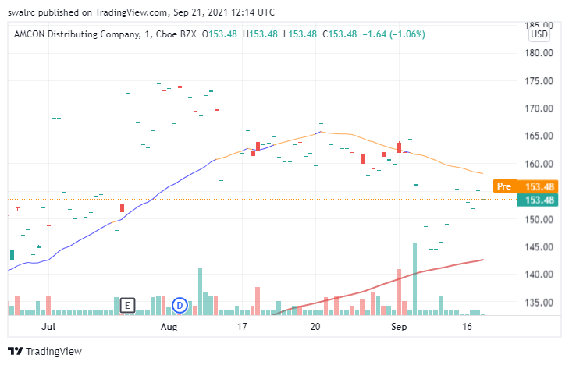

**If you're unsure about the float, you may also use Google to look for a stock's float.**

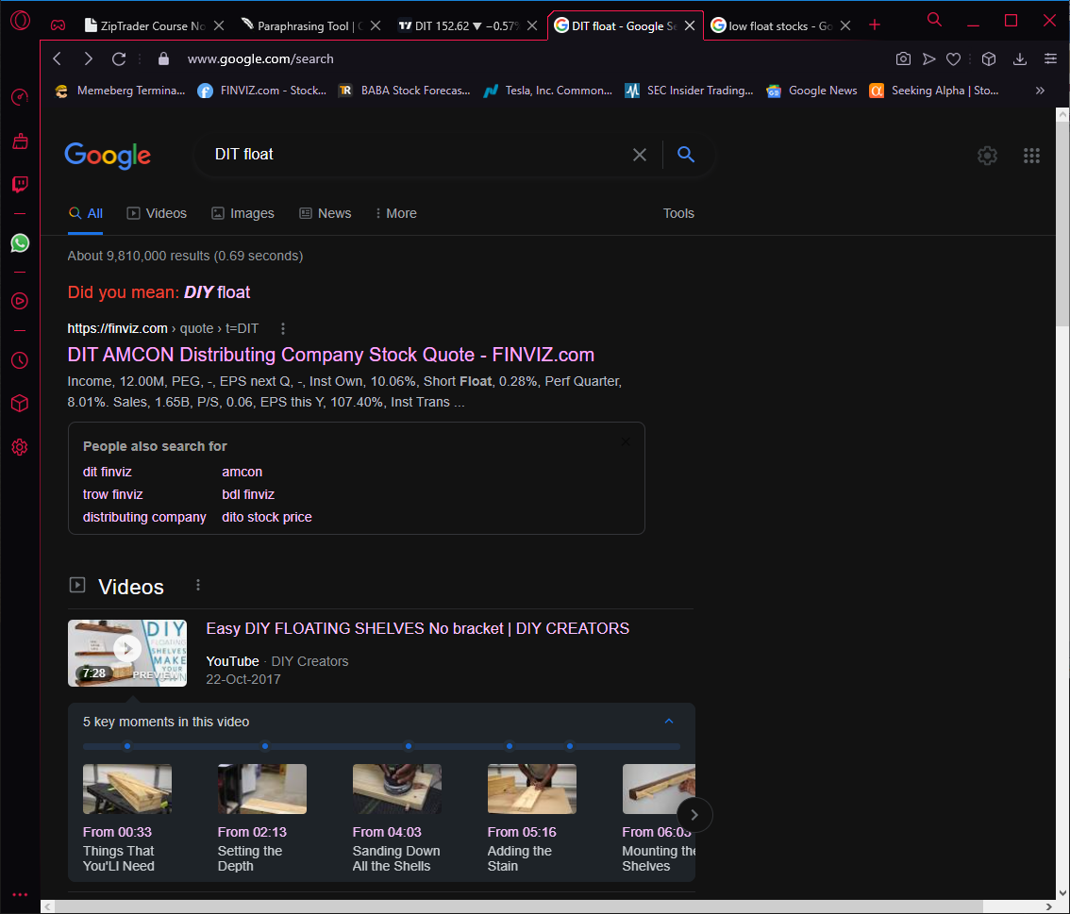

**Below is the data from finviz.com**

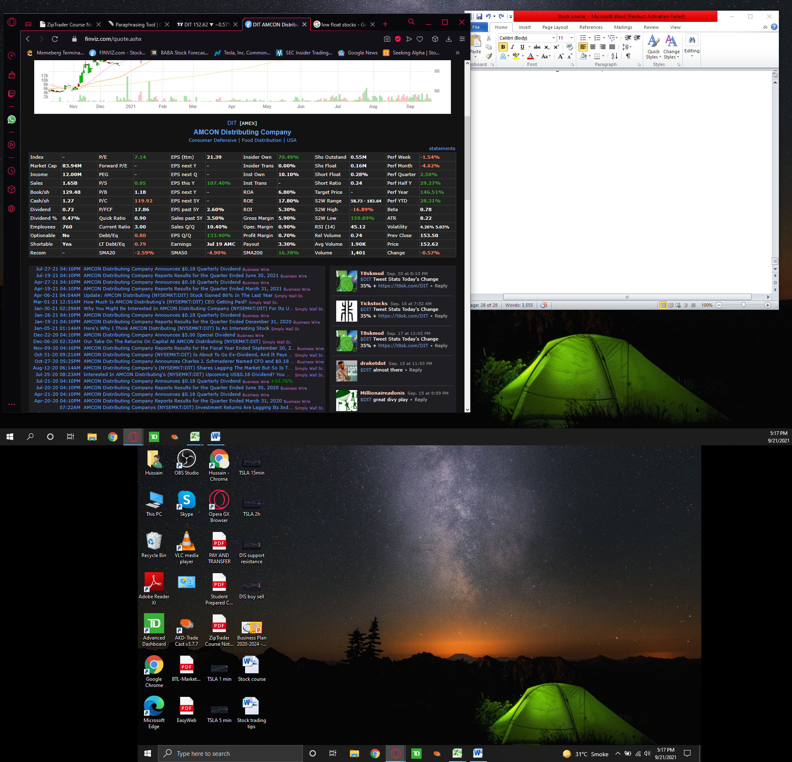

**Using the Pre-Market and After-Hours Markets**

**Pre-market and after-hours trading is where a lot of the big swings occurs. These are visible in your broker account. Some brokers will not show the premarket data on charts and some brokers will. If premarket chart data is not available you can also look at the bid & ask and monitor the fluctuations from there as shown below in the yellow box. During premarket hours the bid & ask will be changing every second.**

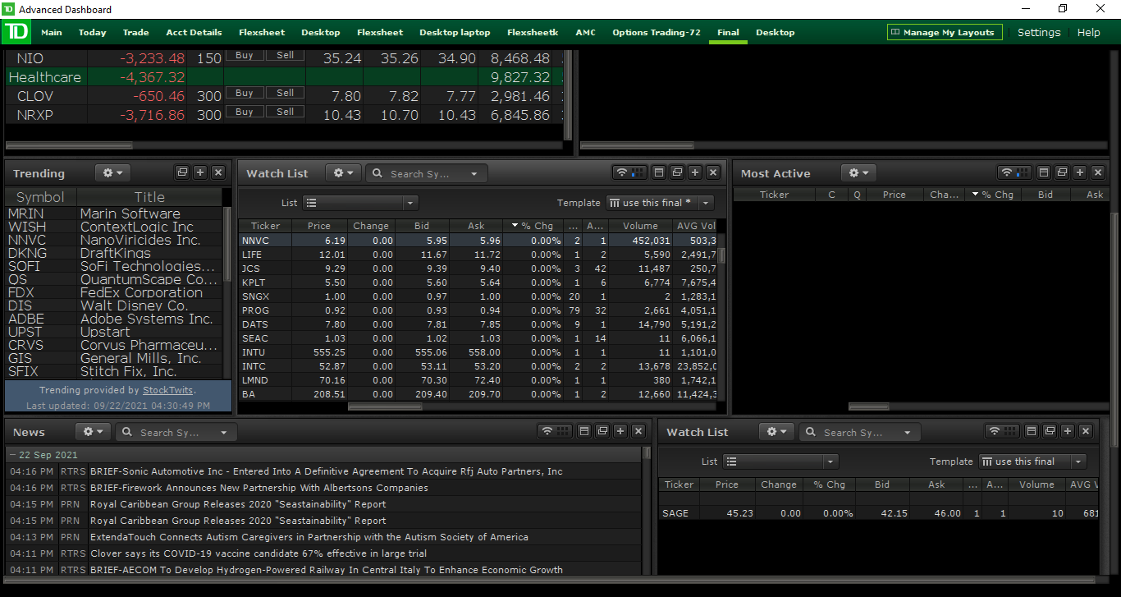

Pre-market hours are from 4 a.m. to 9:30 a.m. EST. After hours is from 4 p.m. to 8 p.m. Because many traders and institutions only trade during market hours, non-market hours are usually less liquid. We, as retail investors, have the option of trading during business hours. The only issue will be a lack of liquidity. That implies there isn't much movement in many stocks, and if there is, it's likely to be erratic.

That said, the last hour or two of Pre-market hours, i.e. 8 a.m. to 9:30 a.m., is more liquid. This period may also give us with price movement to trade-off. Because many firms post their stock news and announcements after business hours, this is a fantastic opportunity. They don't do it throughout the day since it may have an impact on the stock price. By watching the reaction in the after-hours/pre-market, we may see these expected results and take a position ahead of time. In the instance of $PATH, for example, an positive earnings report was released, which was seen as positive news, and the stock's price fell due to profit taking from the company.

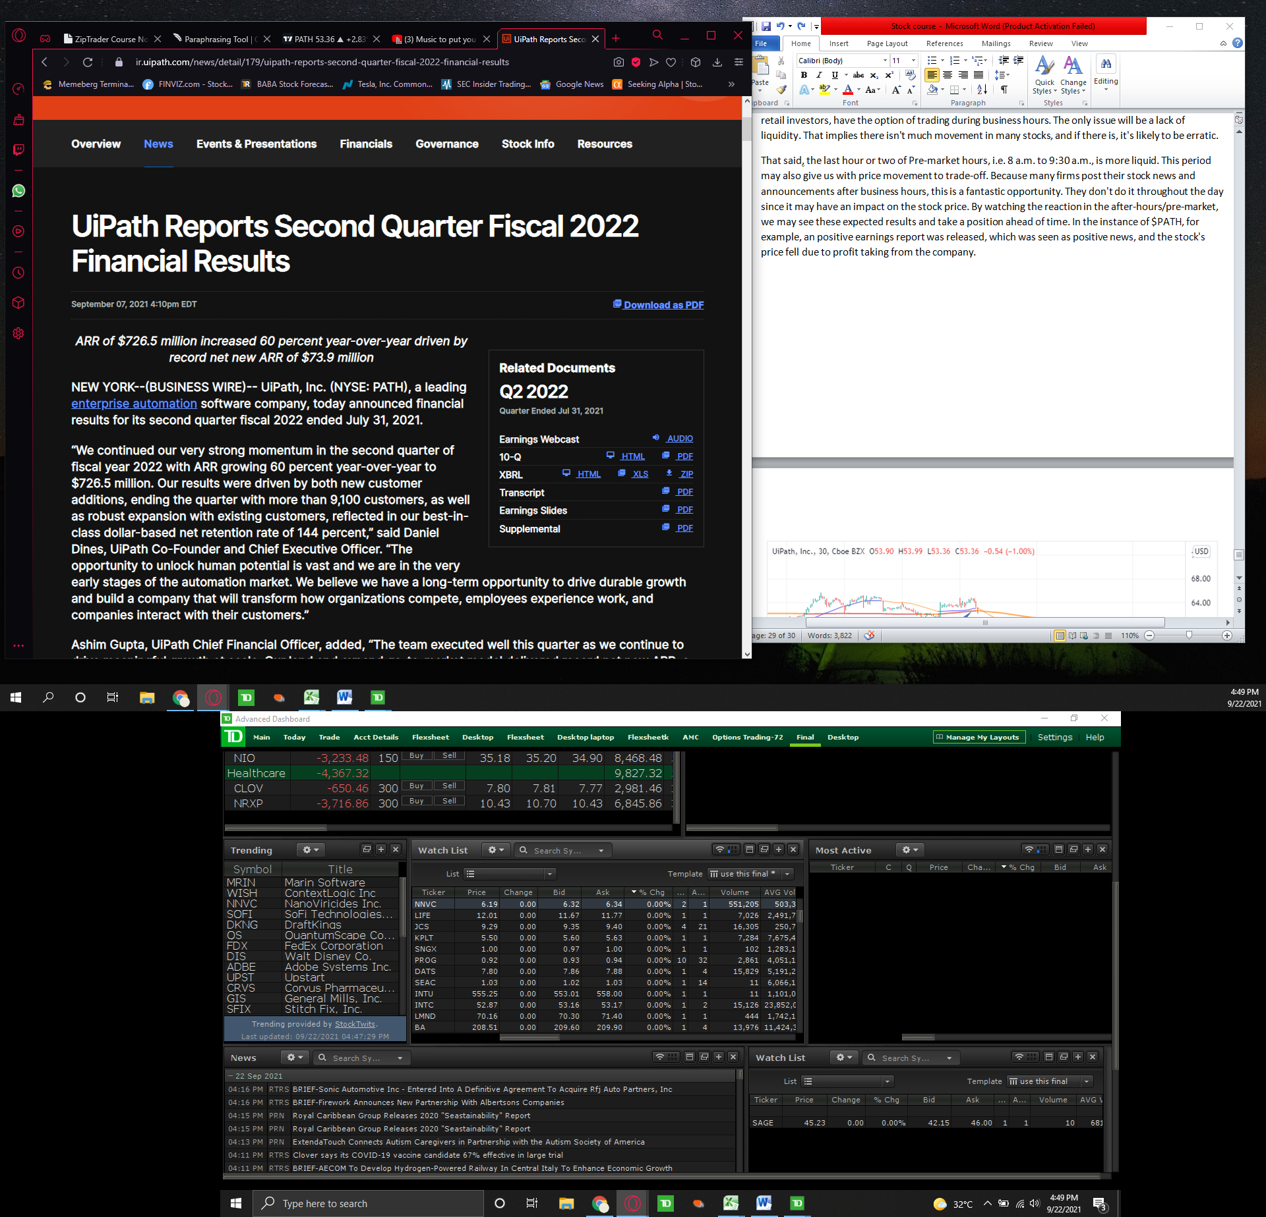

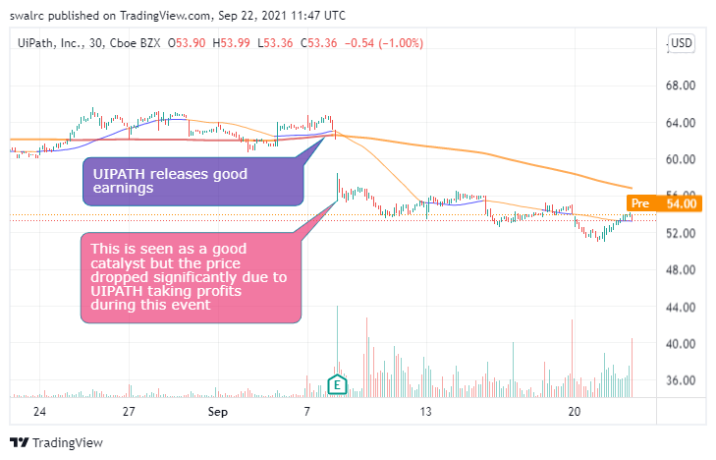

The pre-market phase is equally crucial. You may spot indicators of an uptrend before the market even starts if you keep an eye on it. Take, for example, $HLBZ

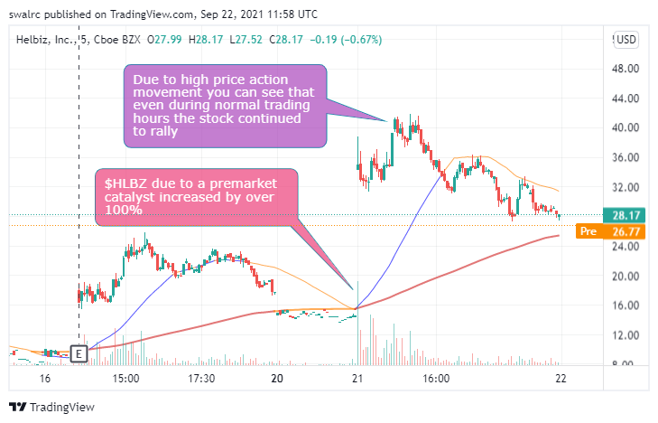

Below you can read the pre-market catalyst for HLBZ which caused it to rally.

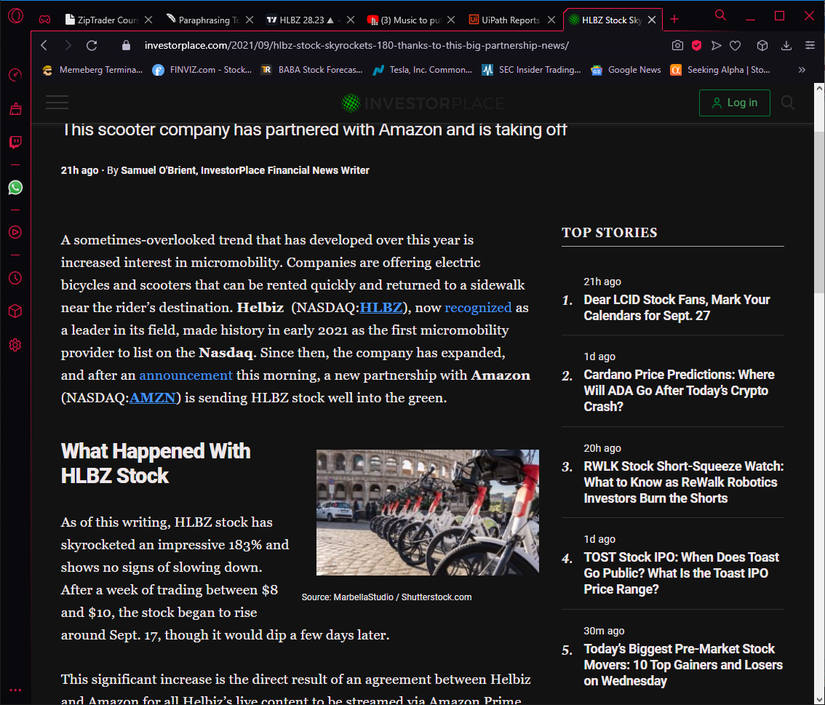

Pre-market has the advantage of allowing you to enter at a low price and then sell out during regular market hours. The disadvantage of after-hours/pre-market trading is that due to the low volume and float, you are considerably less likely to be executed into and out of positions. There are certain exceptions, such as a stock that attracts a high number of investors in after-hours/pre-market trading would have increased liquidity. This may be a fantastic chance for you to trade-off. You may check for equities with significant volumes in after-hours/pre-market using a scanner, which we shall cover later.

For example, in the instance of $NRXP, there was a significant buying in the pre-market, thus you can expect it to rise when the market opens. In this sense, after-hours/pre-market trading may be quite beneficial to us. This isn't always the case though. As we can see with $NRXP after the good news catalysts the premarket action was amazing. But during regular trading hours we did not see that same price action. We saw the price come down and not touch the pre-market highs.

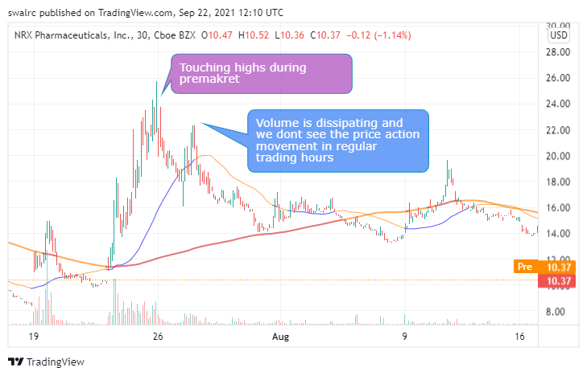

It's worth noting, however, that after-hours/pre-market prices only carry a little degree of future price significance. Due to low volume and floats, this after-hours/pre-market price movement is too erratic for our indicator setup to operate. As a result, don't utilize after-hours/pre-market trading to predict where a stock will go in the future. Use it just as a tool to observe how people react to news in the after-hours/pre-market. If you absolutely want to trade after-hours or before the market opens, make sure you utilize a limit order because prices might fluctuate erratically. Also, ensure that you enter at a favorable time according to the market hours.

**Important Points to Remember**

* After-hours trading is from 4 p.m. to 8 p.m. EST, while pre-market trading is from 4 a.m. to 9:30 a.m. EST.
* We have access to after-hours and pre-market trading as retail investors.
* These hours can help us understand how the market reacts to news that is issued outside of usual trading hours.
* Due to limited volume, stock movement during after-hours / pre-market is erratic.
* You may use specific scanners to see if there is a lot of trade going on in the pre-market hours and then take a position when the market opens.
* During these hours, only trade using limit orders; otherwise, you may end up with a very poor entry point.
* If you wish to trade during these hours, make sure you receive a favorable entry price in comparison to the price during regular trading hours.

**How to Choose the Right Size for Your Trade**

The amount of money you should utilize per trade is referred to as position size. There are three primary variables that influence this.

The amount of capital

The level of risk tolerance

The individual’s skill level

You shouldn't use real money if you're a newbie. Trade paper money for proofs rather than promises. Start small after that. You should start with a few of hundred dollar holdings until you can economically increase them. When you've completed this and have progressed to the Professional stage, you can take on more risk.

**Example**

Set a goal to grow your capital on a scale which is realistic. You can set a goal on a weekly or monthly basis. Always make sure to do your accounts to see if you are meeting your goals.

For instance, if you have a long-term trade that offers you 10% per month and a 10% potential each week utilizing day trades. You should invest your money in day trading. Take the most efficient position that will provide you the most profits without putting your money in a bank. You can distribute $50,000 in this way if you have $50,000 in capital.



Never trade your entire account in a single transaction. This is not a good situation. Your account will ultimately be blown up as a result of this. This is a really terrible habit to get into. Also, you should never trade with more money than you can afford to lose. Limit the amount of capital you utilize in a trade to no more than 20% of your total account value.  Even 20% is pushing it as a beginner trader.

If you intend to make a living from trading, you should develop the practice of not risking your whole account on a single deal. This is due to the fact that you will blow out your account and then have no money to return to the game. It's also a good idea to have some money in cash in your account. This manner, if any of your positions go bad, you may re-grow your account. You should also consider whether a stock is less liquid, such as a penny stock. This is because, due to limited volume, it is difficult to execute a position without impacting the price.

**Things to keep in mind**

Do not risk more money than you are willing to lose while trading.

Do not risk more than 20% of your account on any single setup.

Leave a portion of your trading account in cash.

The highest return positions were obtained through maximizing efficiency.

**Using Indicators and Patterns to Make Trades**

Indicator Focus: Putting the Odds in Your Favor

How well you control your probabilities of success in trading determines your trading profitability. Our indications and techniques will aid you in this endeavor. Even if the indications can't help us forecast the future, they can show us how likely we are to succeed. In this part, we'll go through each of the indicators.

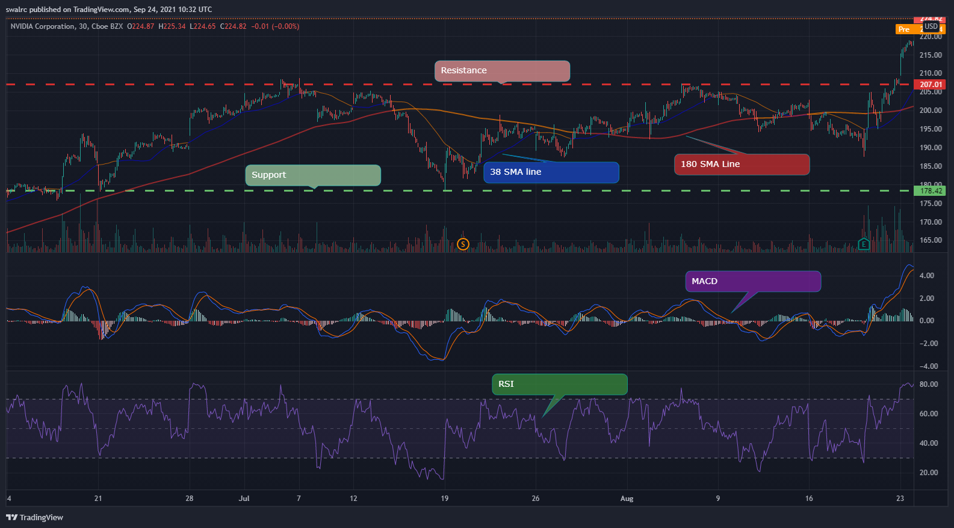

* The RSI (Relative Strength Index) is a tool that helps us determine if a stock is a good buy or not. We can buy a stock when it is oversold to increase our chances of success. Investing in oversold conditions does not guarantee success. It's only one aspect that increases the chances of success in our favorite game.
* Support and Resistance - We may use this to evaluate our risk vs. return ratio.
  + This isn't to say that we'll buy any stock that has a higher upside potential than a lower upside potential. First, we need to see indications of a recovery.
* SMA {Simple moving average} Lines-We use SMA lines to find entry points where we have higher odds of a continued increase as compared to decrease
* MACD (Moving Average Convergence Divergence) is a strength indicator. It will be explored in greater depth at a later time.

Finding Entry and Exit Points in SMA As indicators, we have two SMA lines. They function by taking a specified time period and averaging the results, which is reflected on our price action. The greater the time period, the less responsive to recent events it is, and vice versa. Our short-term SMA line is blue, while our long-term SMA line is red. The instructions for setting them up are listed below.

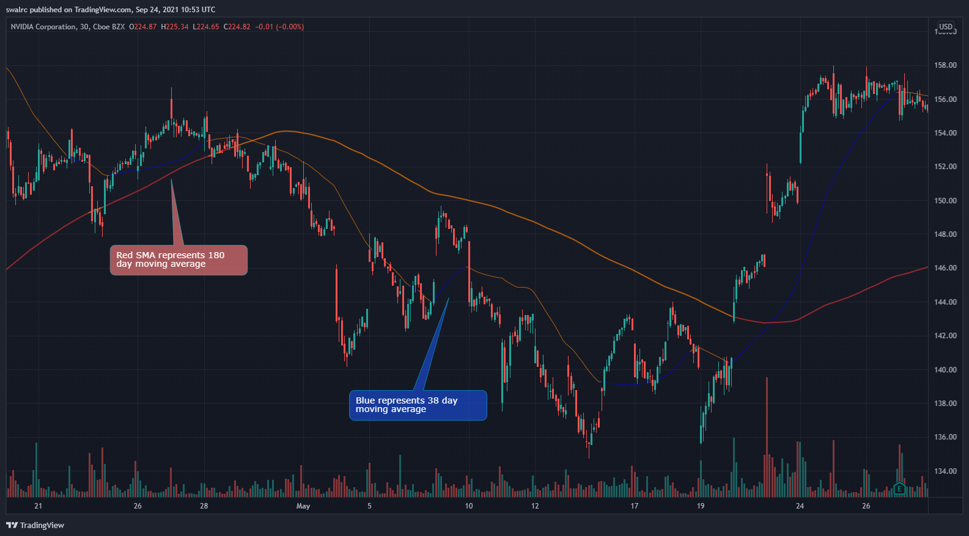

SMA Line (Long-Term) (RED) Our long-term SMA line is red, and it indicates directional strength. We are in an upward direction if we are above the red SMA line, and we are in a downward way if we are below the red SMA line. The following are two examples of this.

Upward

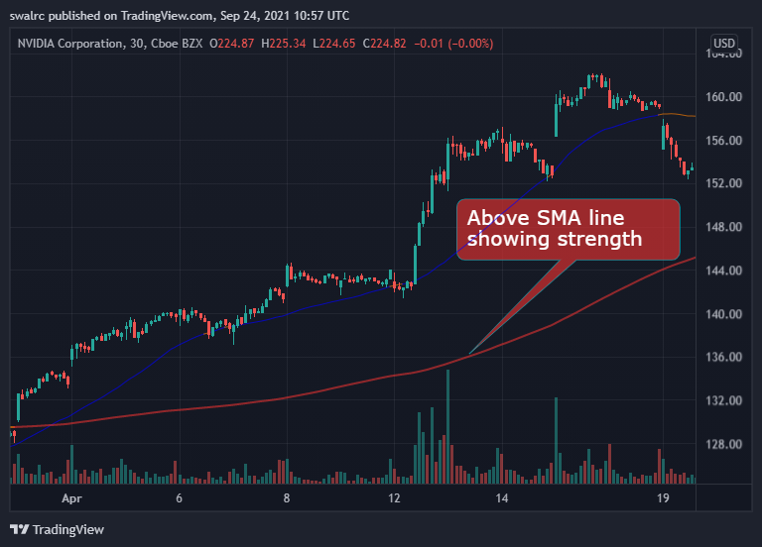

Downward

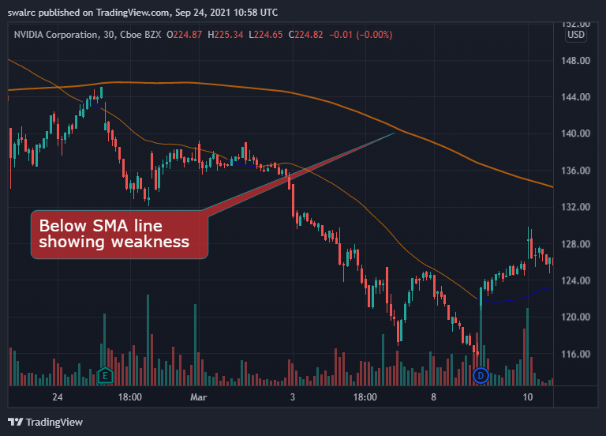

The greater the gap between price action and the Red SMA line, the more powerful the direction.

The importance of direction stems from the fact that you want to execute on the side of the direction. If you execute on the side of direction rather than against it, you will have an additional element working in your favour. That is, in essence, a motivating element. Every positive signal in your favour is a motivating element. A stock that is going upwards is more likely to continue rising upwards than a one that is trending downwards.

SMA Line (Short-term) (Blue) Price strength is shown by the blue line, which is our short-term SMA line. We utilise the short-term SMA line to evaluate minute-by-minute price strength rather than overall direction, as we do with the red line, because it is more reactive to current price activity.

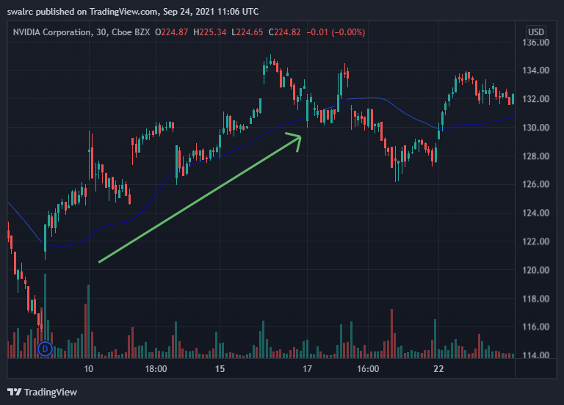

When price movement breaks above the short-term SMA line, it indicates that price strength is present.

The right time to enter a stock?

CONFIRMATION occurs when the first candlestick remains above the short-term SMA line.

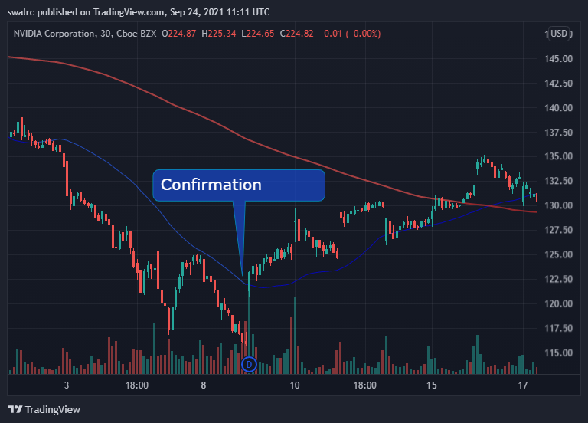

Yes, we are currently in an upswing, as confirmed by a confirmation. It may theoretically still fall down after that, but confirmation is critical since it lets us to enter when the chances of the uptrend continuing are strong.

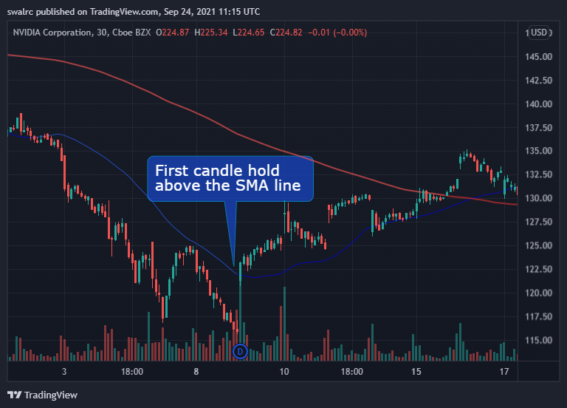

Price Action Intensity The gap between price movement and short-term SMA lines indicates the strength of the price action. The weaker the price action is in relation to the SMA line, and the stronger it is in relation to the SMA line.

We will be able to ride the price strength while also being able to quantify it in a real sense if we buy in at confirmation. We may then enter a position based on confirmation and maintain it until it loses its strength.

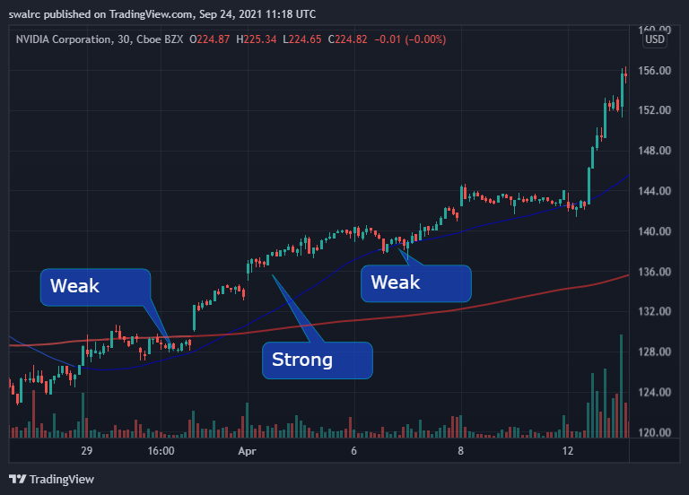

When should you leave a position? The moment at which you should leave is determined by how many uplifting variables you have in your favour. You may simply exit upon VALIDATION if you have a lot of upside potential, are above the long-term SMA line, and are still below fair value (RSI will be discussed later). The first candlestick that falls below the short-term SMA line is considered valid.

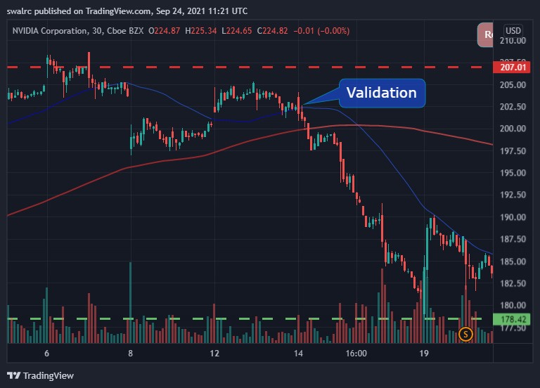

If you don't have all of these elements working in your favor, your position is much more vulnerable. In such scenario, it could be advisable to leave at an earlier warning sign, such as the first time the price action crosses the SMA line, or even sooner if the rising variables in your favor are favorable.

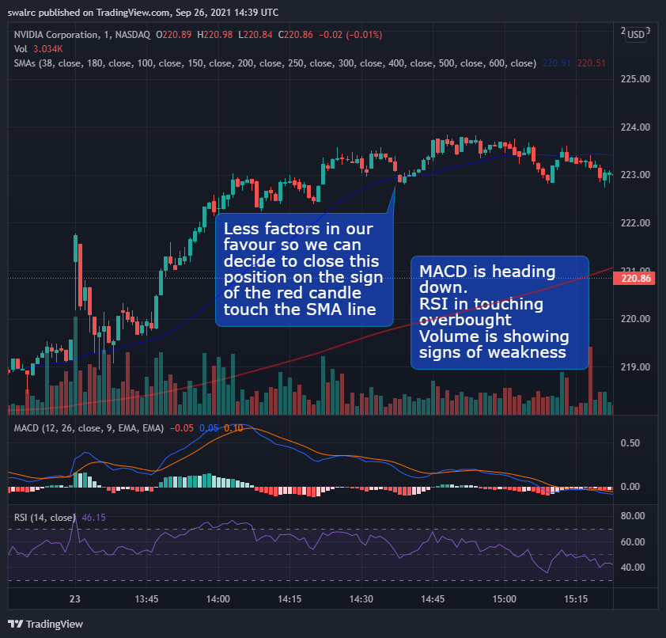

In this approach, you're attempting to tilt the chances as much as possible in your favor. This is done by contrasting the elevating and depreciating forces. It's critical to assess the sensitivity of your position by calculating how many factors are working in your favor. As a general rule, we should leave on a regular validation point if we have a moderate level of probability (Elevating factors) in our favor.

**Remarks in General**

The SMA lines are a basic trading technique that we may use to trade the stock market. They track two factors: price strength (blue line) and directional strength (red line) (Red line). As we progress through this course, we'll notice that SMA lines appear in virtually every case. We'll combine all of the signs later in the course to discover how to calculate our chances of success.

**Example**

We'll use a White Square to indicate the confirmation points and a Red Square to highlight the validation points in these examples.

$SNAP is the first example.

Here, we can observe how $SNAP plummeted after the market opened. Then it battled its way around the long-term SMA line until it broke through and generated some price movement, as shown below

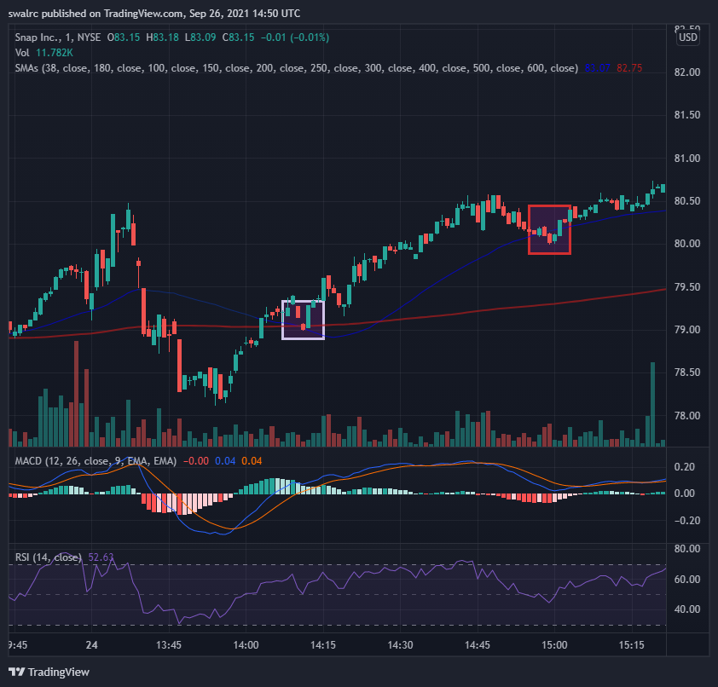

Important Points to Remember

Here are a few key points to remember.

To show the directional strength, we utilize the long-term (Red) SMA line.

To determine price strength, we utilize the short-term (blue) SMA line.

When we obtain confirmation on the short-term SMA line, we buy a stock (First candlestick holding above) Keeping in mind that there are additional variables in your favor.

We sell a stock when the short-term SMA line is validated (First candlestick holding below) Keeping in mind that there are additional variables in your favor.

Confirmations aren't meant to be used as a blind entrance point. They should be used in conjunction with existing excellent installations. Validations aren't only a way to get out of a situation. They'll be assessed on a variety of other things as well.

Validations aren't only a way to get out of a situation. They'll be assessed on a variety of other things as well. If your position is critical, you can leave sooner.

Finding a Good Deal with the RSI–Relative Strength Index We focus on buying on good deals as consumers, but for some reason, many take the opposite attitude when it comes to the stock market. People are more likely to purchase when a stock is rising in price, indicating that it is already overpriced. When buying a stock, we may utilize RSI to identify a good offer. When purchasing stocks, there is a risk of FOMO (Fear of Missing Out) if the stock is rising in value. You could believe that because of the stock's prior performance, it will continue to do well, but you can never be sure with stocks. People keep taking positions because they are afraid of missing out, and when this happens throughout the market, it produces a bubble that can collapse.

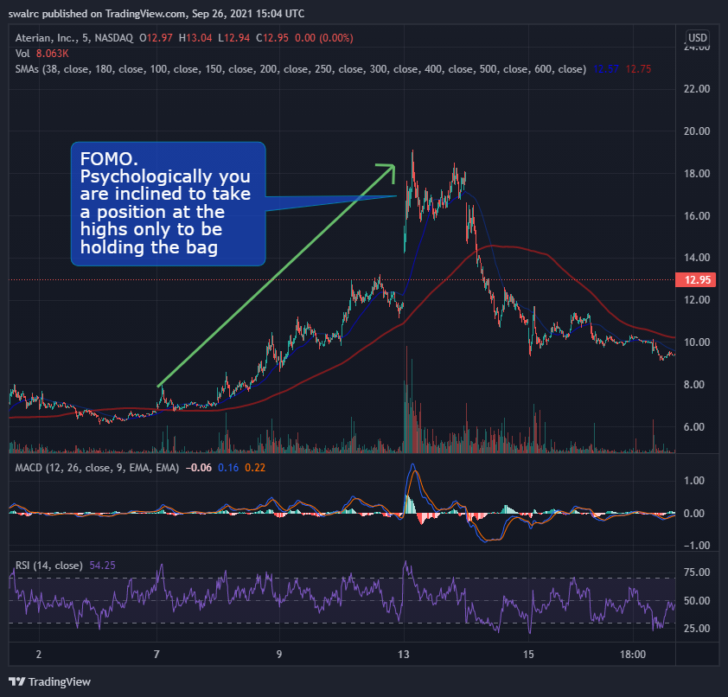

If you're investing because you believe it will continue to run because it has in the past. However, because this position is overpriced, as evidenced by the RSI, it is less likely to continue producing profits.

RSI is an acronym for Repetitive Strain Injury. On the chart, there are two RSI lines, one for Oversold and one for Overbought, as seen below.

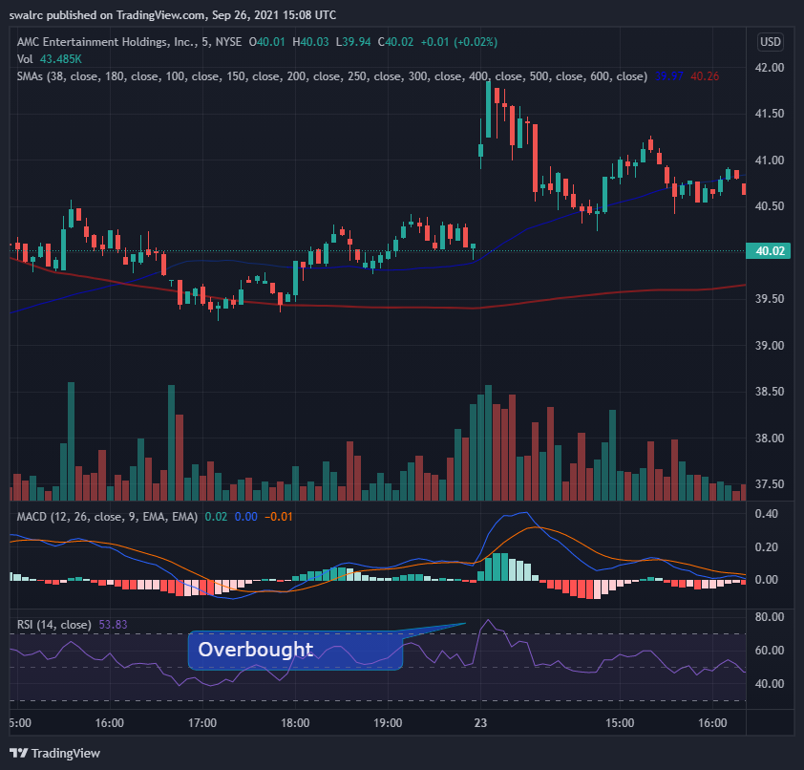

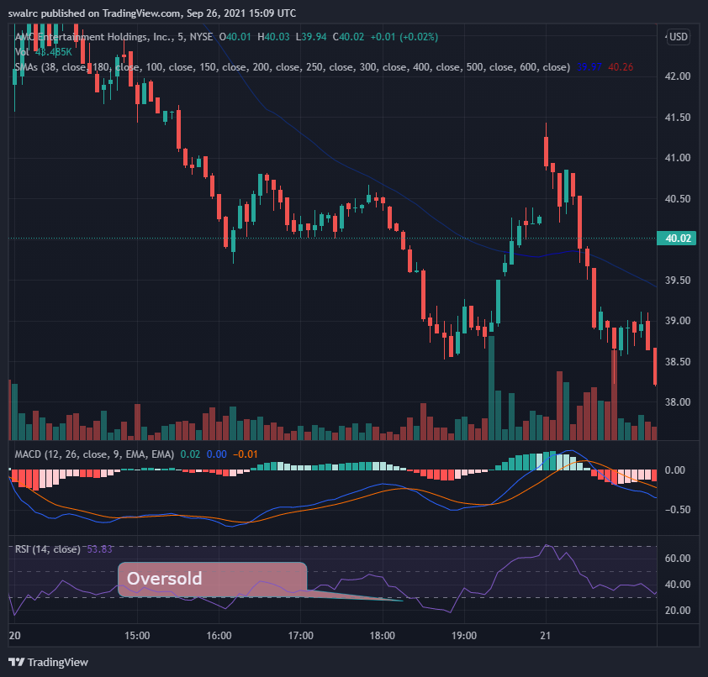

It is termed Oversold if the stock is trading below the oversold line.

The stock is deemed overbought if it is trading over the overbought line.

In the RSI, the exact center line denotes fair value. So anything below the center line is below fair value, and everything above it is over fair value.

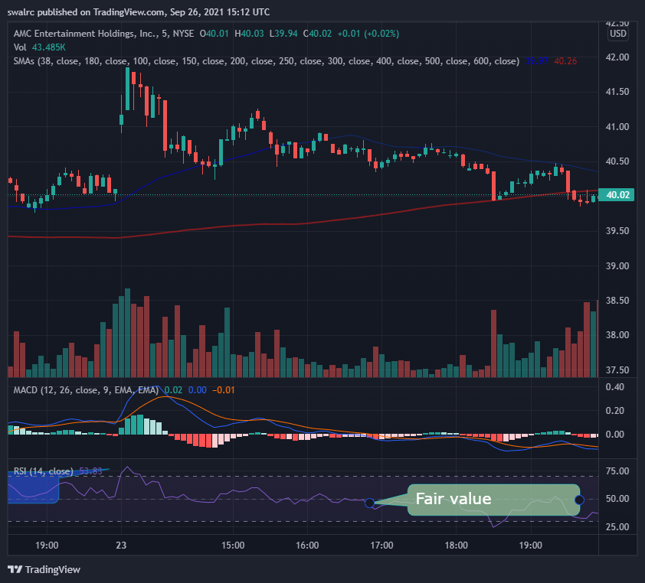

A stock's price swings a lot, as it should. The RSI algorithm crunches and puts all of that data together to determine if it's a good or terrible deal based on prior price movements. You can see in the image below that the RSI should be overpriced at position 1, but it wasn't in position 2 even though the price was higher. This is due to the fact that RSI rates it based on prior price points.

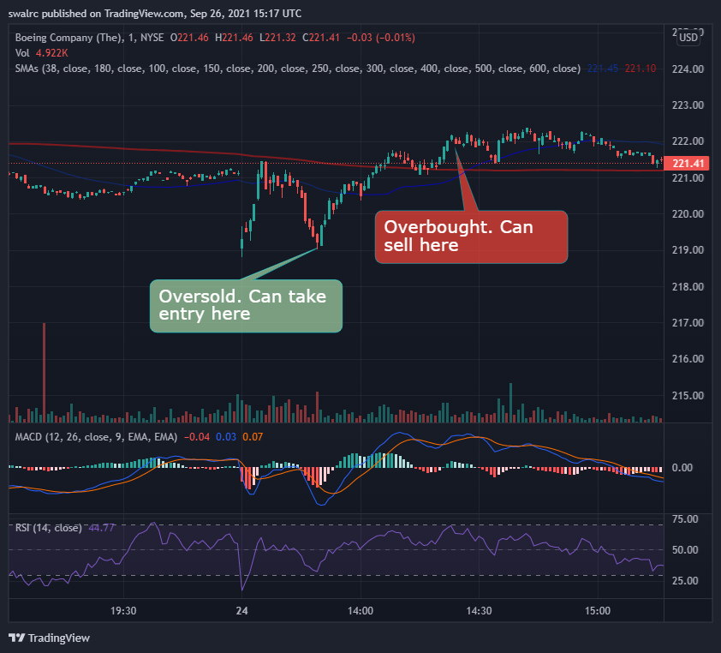

We may utilize the RSI to take trades when a price moves too much up and down.

$TSLA, for example. Even though we had several solid entry opportunities upon confirmation, purchasing on an entry point that was also oversold on the RSI would have enabled us to limit our downside because we were receiving a fantastic bargain, as seen in the $TSLA example below. We may also increase our profit margins in this way.

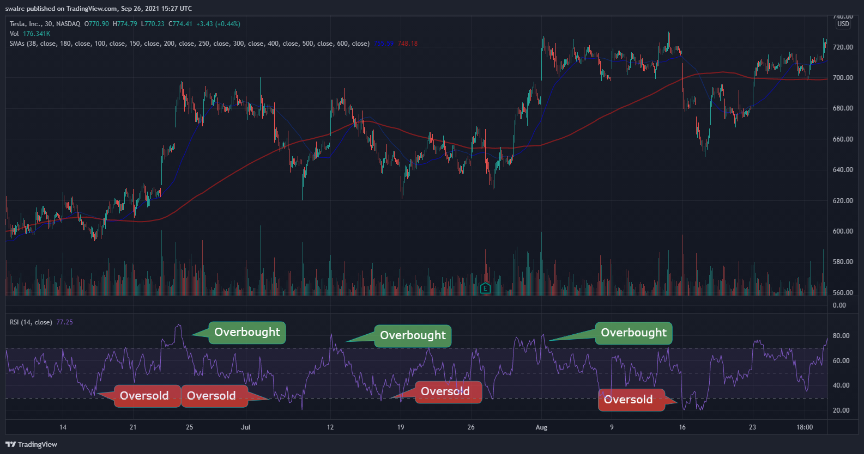

You might have just waited till we hit fair value because this stock has a history of overselling and then recovering to fair value. We'd also see that we'd returned to the opening resistance and had sold out at that time. If you had left certain moves on the table, you would have made approximately 10%. That is the power of elevating factors; when correctly employed and analyzed, a solid mix of elevating variables may help you increase your chances of success

After then, you can be on the lookout for the next oversold situation. As seen below, the next oversold position occurs here. However, there are just two uplifting elements pushing us in the correct path in this case. We've been oversold, and we still have upward potential till we hit the prior resistance. We also have depreciating factors because we are trading below our SMA lines on both sides. As a result, purchasing here would be difficult.

Instead, purchasing it now upon clean confirmation (see below) would have provided us with a comparable entry position to when we were oversold, as well as the ability to purchase at a period of price strength rather than weakness. This also provides us with an entrance point where we already have a history of recovering from.

You might be critical here because it did continue to run after that. The issue is that, while it did continue to run after that, it was an entirely new run-up with a completely different entry point. How did you manage to locate it previously? It has never been feasible to time this previously, and we are looking for long-term consistency.

When a stock is overbought and then continues to run, it becomes a momentum position. The problem is that it lost its price strength when it battled over the short-term SMA line. That implies we wouldn't have had enough enticing elements to entice us into a position until we had another confirmation.

That is the disadvantage of risk management. You won't be able to complete the journey. As a result, you must concentrate on making certain of the moves on a regular basis. This is the cost of maintaining consistency. Trading is a game that is won by a series of trades rather than a single trade. Don't become greedy and hold on even if your motivating reasons have shifted to demotivating considerations.

Important Points to Remember

Here are a few key points to remember.

We utilize the RSI to determine if a stock is a good buy or not.

Oversold (below) and overbought (above) are the two lines on the RSI (above)

When the stock is oversold, the RSI can assist us find suitable entry targets.

To properly assess the most lucrative entry moment, you should combine RSI with other indicators.

RSI is only a tool that, when paired with other elements, enhances our chances of success. This is accomplished by maximizing our gain while reducing our downside by obtaining a better deal.

**MACD (moving average convergence divergence)**:

Gauging Strength MACD is a new technique of measuring price strength and momentum. It may be found immediately below the chart, as seen below.

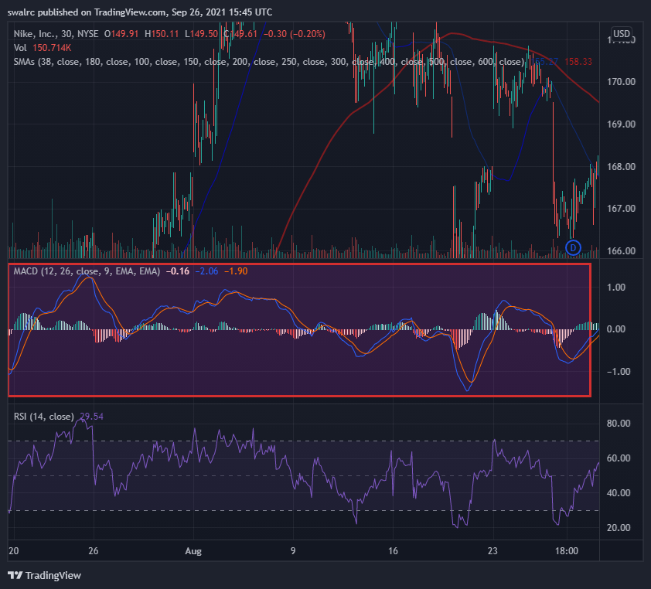

**What is the MACD and how does it work?**

Positive price strength is viewed through the MACD in a different light than negative price strength. We enter a phase of positive price strength when the MACD crosses over

, i.e. the blue line crosses the yellow line, and vice versa.

The greater the price action the wider the gap between the MACD lines & vice versa.

The MACD's histogram bars can also be used to determine the strength of the price action. The higher the activity, the higher these bars will be. In reality, it's quite similar to SMA lines, but from a different perspective.

When you're a newbie, looking at the MACD to assist you evaluate price strength is typically extremely beneficial. On the MACD, being in a positive price strength region is an elevating element, whilst being in a negative price strength territory is a depreciating component. It has a strong connection to the SMA lines, which aids us in assessing price strength.

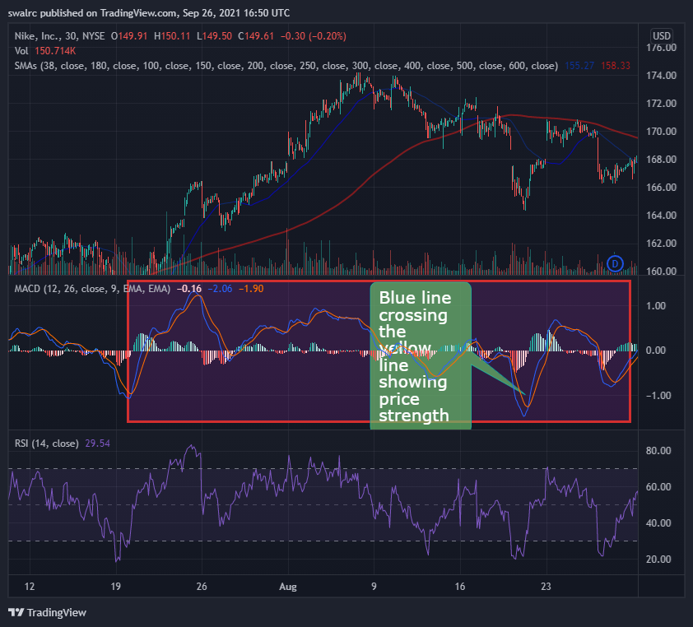

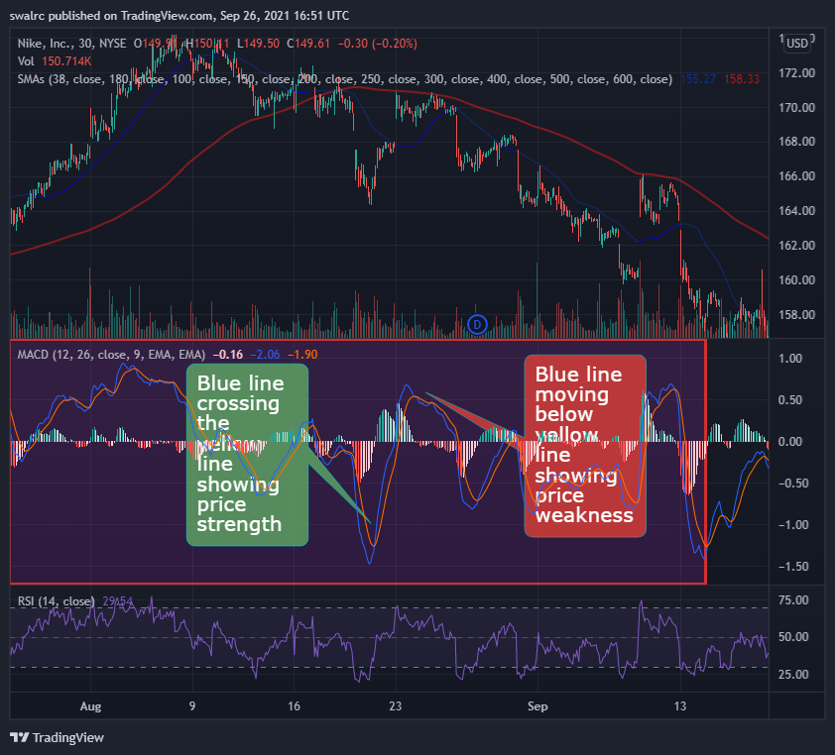

*Find 3 examples of this same movement in the MACD and use them as future references

**Important Points to Remember**

Here are a few key points to remember.

The MACD indicator is used to determine the strength of price movement.

It gives comparable information to the SMA lines but in a more lighted style.

When the blue line crosses the yellow line, it indicates a period of positive price action and vice versa.

Histograms depict the price action's strength.

The better the price movement, the larger the histogram.

It's Critical to Have Direction. We'll talk about the importance of directional strength in this lesson. Our long-term SMA line, as we all know, is the directional SMA line. Price activity above it is regarded rising direction, while price action below it is considered downward direction.

When a stock crosses the long-term SMA line downwards, it is deemed to have accepted a downward direction. As seen in the diagram below

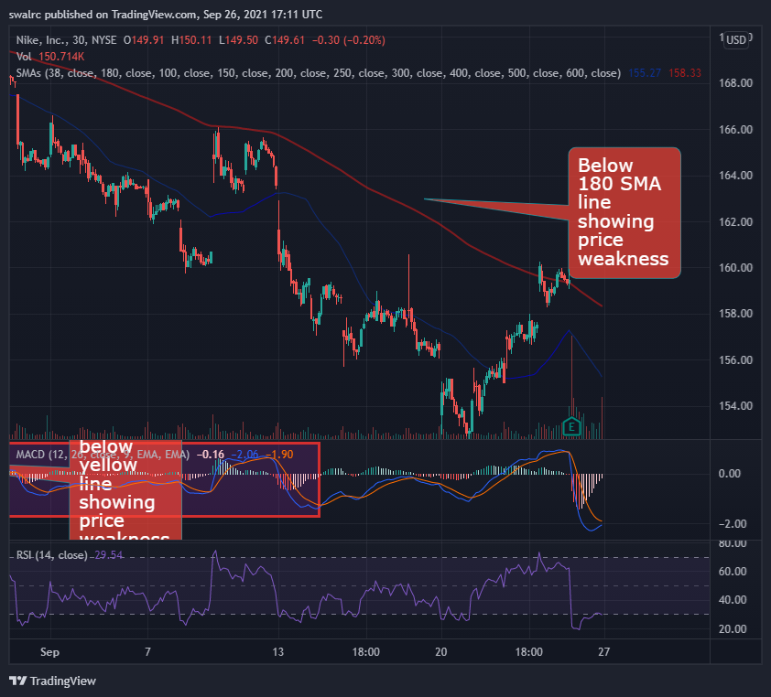

Upward Movement When a stock crosses the SMA line higher, it is deemed to have accepted an upward trend. As seen in the diagram below.

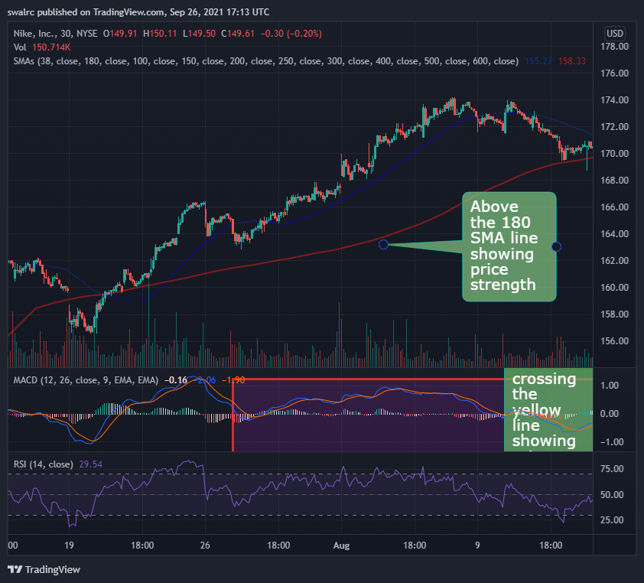

Rejection of Direction: A stock is said to have rejected a change of direction if it gets near to or crosses it for a short period of time before returning to its previous direction. If this occurs, the previous trend will become much stronger. This is due to the fact that investors now know the stock has tried the downside and failed. This indicates that it has strength in its previous direction (Positive).

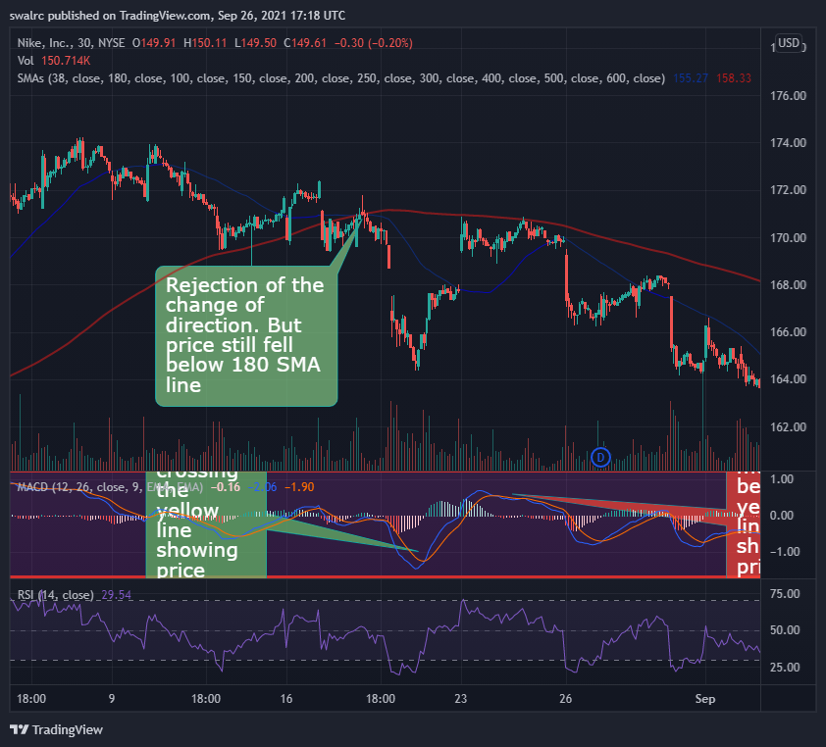

Price movement is uncertain. NETFLIX's direction was uncertain, as it tried the directional change many times during the INTRA day chart. We don't enjoy trading equities with a skewed trend. We do this because we want to trade in a direction that has a good chance of continuing.

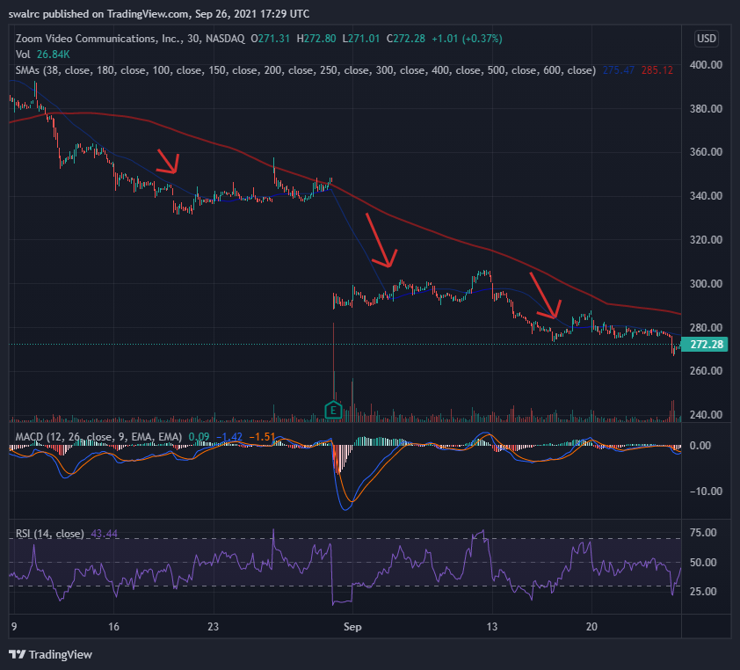

Price movement is uncertain.

$AMZN direction was uncertain, as it tried the directional change many times during the INTRA day chart. We don't enjoy trading equities with a skewed trend. We do this because we want to trade in a direction that has a good chance of continuing.

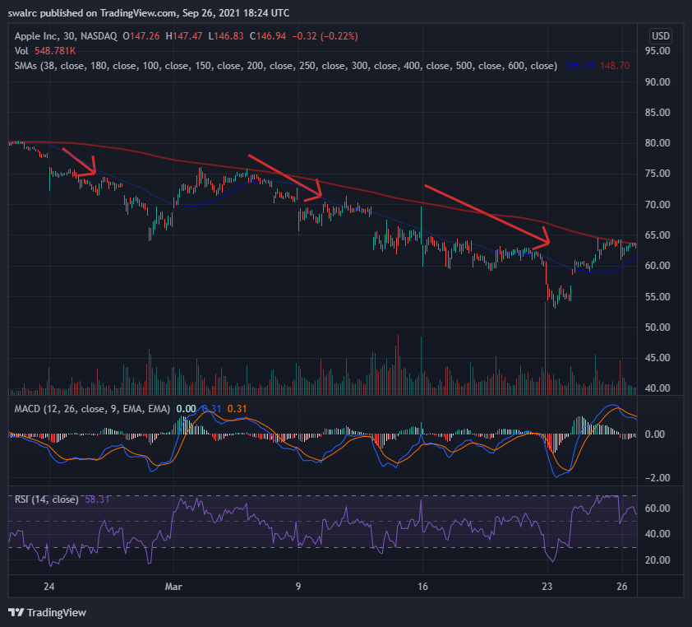

A Crucial Point Avoid trading against the trend because this is a significant depreciating factor. The following are some examples of this. Even if stock prices have plummeted, it makes little sense to acquire a stake if the stock is headed lower in the long run.

*find 3 scenarios similar to the above chart

**Important Points to Remember**

Here are some key takeaways:

Direction is extremely essential and a major uplifting element;

A stock is more likely to continue in an ongoing direction than the reverse;

It is preferable not to trade against the market;

Positive price direction is more forgiving if you make faulty entry positions;

Look for directions on both intraday and long-term charts. Uncertain price action may be tough to trade. You can trade a stock in the negative direction if you notice a lot more elevating causes, but you'll need extremely strong entry points to do so.

**Observing Previous Patterns**

We'll go over some prior patterns that seem to repeat themselves in this section. This can assist us improve our chances of success.

Example 1 AMD

Let's have a look at an AMD example. It has a trend of selling off at market open, as you can see. This trend has the potential to repeat itself.

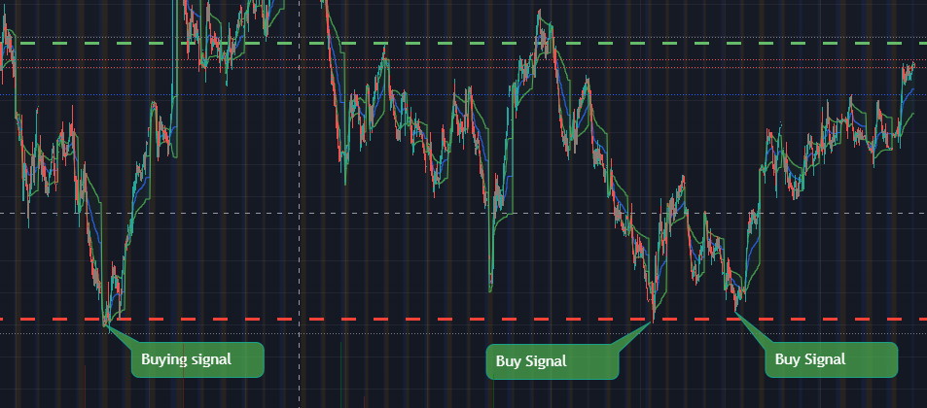

This may allow us to enter at a reduced rate. That is why you should not enter the market just as it opens, since it is more likely to sell off.

**Key Notes**

Over time, patterns tend to replicate themselves. A recurring pattern may be a powerful motivator. On charts, examine at different time periods to determine if there are any past trends. If a pattern has repeated itself previously, it is more likely to do so again. It's also worth noting that, while prior patterns have a tendency to repeat themselves, they don't have to. A pattern might break at any time, thus we should constantly wait for previous pattern confirmation. Even then, a pattern does not have to repeat itself, but it is more likely to do so. In this approach, we improve our chances of success. The more a pattern repeats, the more powerful it becomes, and vice versa.

**Finding the Best Breakouts Has Never Been Easier**

We'll go through how to spot good breakouts in this part. Some individuals advise purchasing equities with higher highs, indicating that they are breaching barriers. However, this isn't always the case. As you can see in the image below, On three instances, this stock has broken through to new highs. There was a lot of upside potential in the first one; we were oversold on RSI in the second one; and if you purchased it at a greater high, you would lose a lot of money in the third one. That is why it is critical to distinguish between a poor and a good breakout

**Exmaple 1** NVDA

Let's look at another example of a good breakthrough. There are multiple breakouts here. We may have purchased at confirmation and ridden the price action until the next confirmation. We might have also purchased it at the breakout.

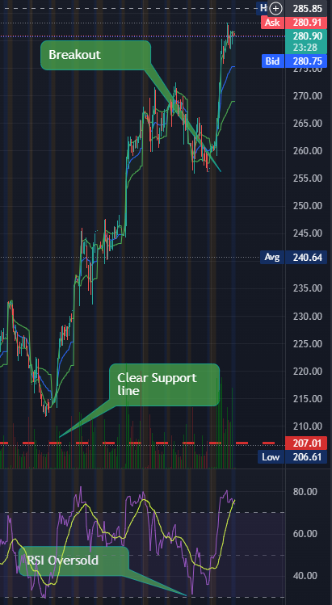

**What distinguishes a high-quality breakout?**

You must first determine whether the breakout is part of a health uptrend, as seen in the example below. We experienced two little breakouts, then pushbacks, and then a major breakout. On the RSI, a robust and long-term uptrend may now be oversold. However, you can benefit from it as long as it provides price action confirmations. The trick is to ride the breakout before it loses momentum at the conclusion, rather than buying in merely because they broke out.

There's nothing wrong with the RSI being oversold. It enables us to get in on a pullback and sell out when the market becomes oversold. Any upward trend in health will be met by a slew of little setbacks.

We've just spoken about support and resistance breakouts thus far. We'll start to see some directional breakouts now. For example, we saw a directional breakthrough and then fantastic price activity in the chart below. We had a breakaway here, and then we put the change of direction to the test. When it was able to hold it and go higher. You should constantly be aware that when there is a change of course, we normally conduct a test. This gives them confidence that they can stop the breakout. This guarantee is crucial.

**$DWAC Below with a clear breakout after being exponentially oversold**

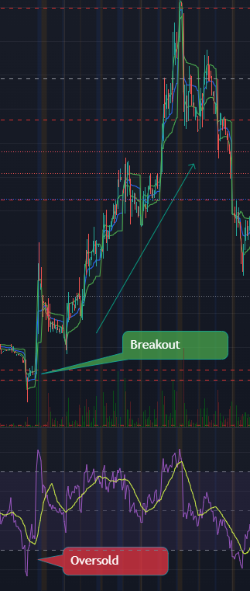

Important Points to Remember Here are a few key points to remember. To determine whether a breakout is robust, check to see whether it is being reinforced, such as by testing a reversal, accepting a reversal, and rejecting it, as well as the health of the uptrend (Over selling on RSI) When it comes to testing the breakup, reassurance is crucial to observe.

**Pattern of Return**

Because of its simplicity, this is one of the most well-known trading patterns. This is the overselling and overbuying trend. This pattern has the potential to significantly improve our chances of success. This pattern can appear on a variety of time period charts, including 1-Day, 2-Day, 5-Day, and even 180-Day charts.

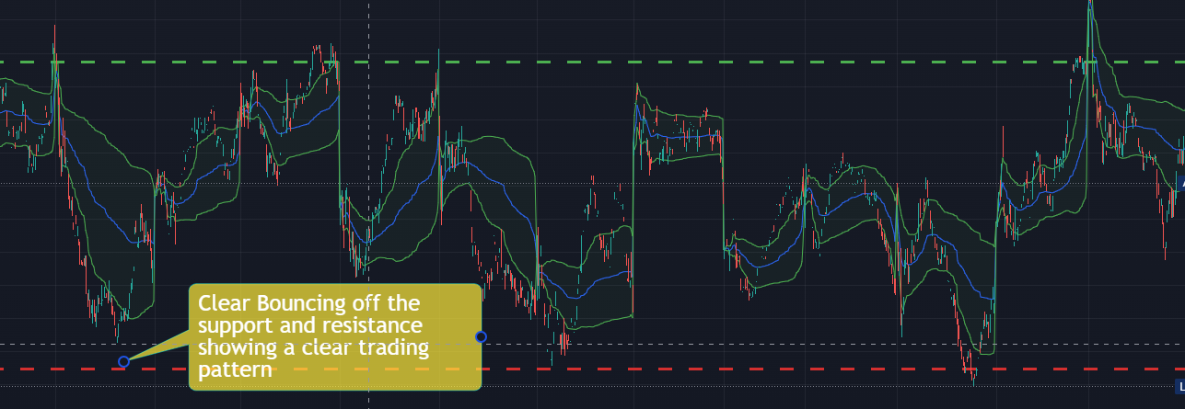

This is the most basic type of design. If you look at the chart below, you can see that we could have simply purchased at an oversold level and sold at an overbought level on the RSI and earned a profit. This is a significant motivator. When used alone, this pattern has a lot of promise, but when paired with the other technical tools, it greatly increases our chances of success.

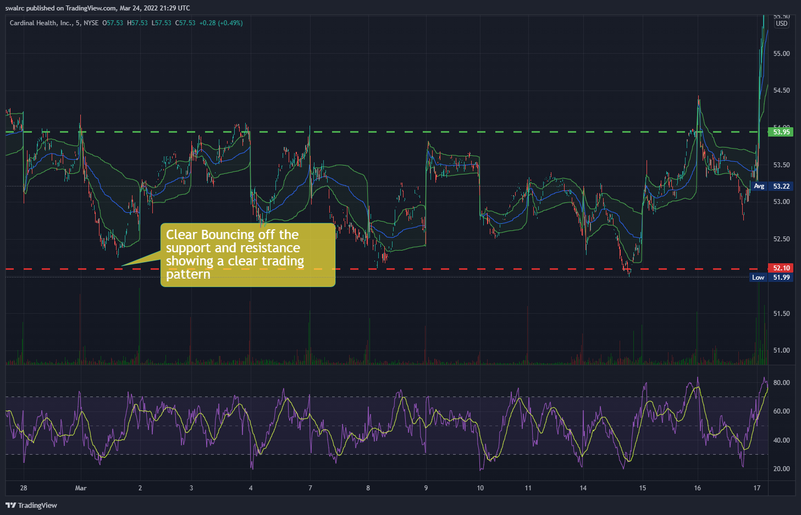

Make sure to keep an eye on the RSI. As you can see by observing the direction of the RSI you can plan your entry and exit for the following trade.

**Important Note**

It's vital to remember that if you have a stock that is continually heading downhill, you'll have a hard time trading it, even with the Comeback King pattern. This is a bad indicator if you have a negative direction.

**Important Points to Remember**

Here are a few key points to remember. The goal is to use the RSI to determine common levels of support and resistance. Oversold-overbought, oversold-fair value, fair value-overbought, and so on are all possibilities. Also, remember that trends tend to repeat until they don't. As a result, you must combine these patterns with additional technical indications to increase your chances of success. Take them as merely motivating factors rather than precise entrance and departure locations. We don't buy stocks just because they're on sale.

**DoubleBottom**

The Double Bottom will be discussed here. As we previously established, the more times a price tests a level, the more powerful it becomes. That is exactly what the double bottom is for. Let's look at an example FB to see how this works.

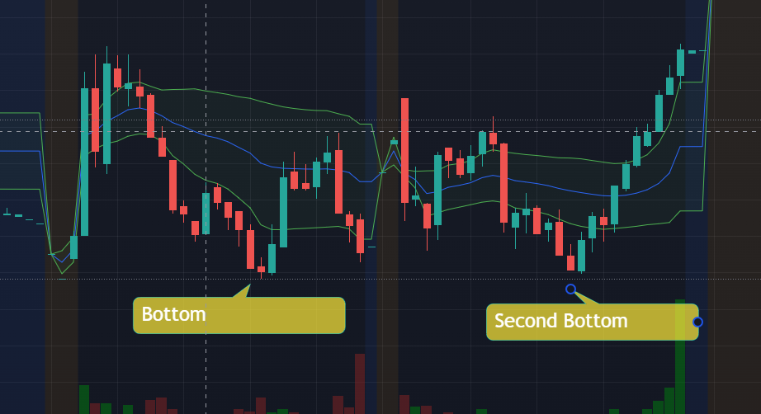

When a stock reaches a double bottom, it's more likely to rise to its prior high, and if it does, it becomes a momentum play, as it did in this case. This is not by coincidence, as we must emphasize. This is because we have a support here, which we have now double-checked. It can only move up or stay flat once it has been established that it has the power to hold on to this level. If it rises, we have upward potential up to prior resistance, and if it breaks that, this becomes fresh support. Remember that old opposition can become fresh support. As a result, we have a huge upward potential following that.

**Important Points to Remember**

Here are a few key points to remember. Double bottoms happen when you hit a support level twice, making it stronger. After that, the stock will most likely only go up or flat. They can then go into momentum positions if they break the obstacle. These are only raising aspects, which is why you must combine them with other technical indications to increase your chances of success.

Choosing the Most Appropriate TimeFrame It's critical to choose the right time period. There is no universal timescale that applies to all circumstances. It all depends on whose side you're on. Fortunately, when choosing a time range, there is one fundamental guideline to follow. The guideline indicates that you should choose a Timeframe that corresponds to the length of your location. In other words, you should choose a time period that corresponds to the length of time you will be in your position.

**What is the support and resistance time frame?**

In such scenario, the situation is exactly the reverse. In these cases, long-term support and resistance levels matter more than short-term support and resistance levels, regardless of the time period. This is because long-term decisions are regarded as more significant than short-term decisions. When a stock falls below its 52-week low, there is a lot of hoopla in the media. It's the same with encouragement and opposition. A company like Tesla, for example, would reach its 3-Year support after several months of decline, and sustaining this support is a major thing. This is due to the fact that you can now get it for the lowest price in the previous three years.

**Example $LCID**

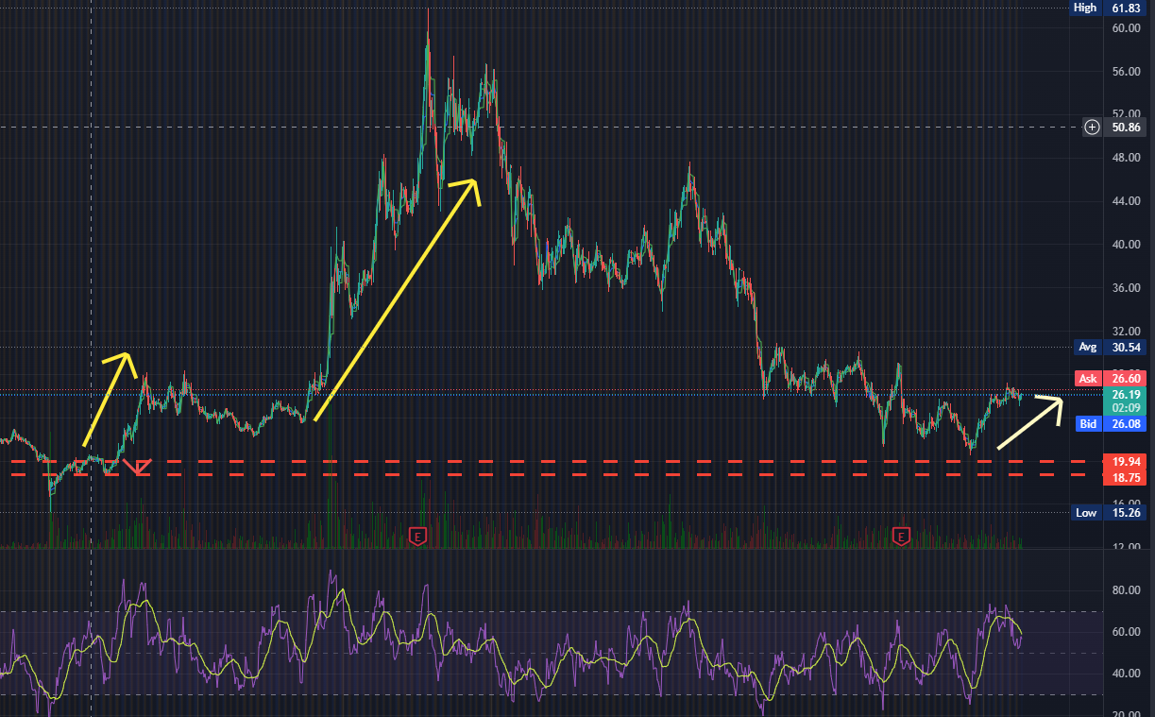

This is also a significant upward indicator since it indicates that we have now reached a discounted price, held it, and are now beginning to run-up. However, if it falls below this three-year support level, it will be a significant depreciating factor.

What are the advantages of looking at the context of this build-up?

Because we want to take a day position, it makes sense to concentrate on the day chart. By taking a look at the larger picture, we can see how strong this move is and how strong the upward momentum is.

After being knocked down for a long time, we can see that this is part of a bigger breakthrough into the upward direction. As a result, we know that any price increase in this environment would be quite strong.

**Important Points to Remember**

Here are a few key points to remember. Focus on the time frame that corresponds to the duration of the position you are going to take. Also watch the longer time charts to see the context of the move. When utilizing several time charts, you can get entirely different signals on the same indicator.

**Squeezing and Measuring Volatility**

We'll talk about volatility and volatility squeezes in this section. Volatility is critical since it is similar to the gasoline that our automobile runs on. There are no transactions if there is no volatility. Volatility is defined as the difference between the bottom and top of the price movement, plus the difference between the bottom and top of the price action. How frequently does it go there?

**$GME short squeeze**

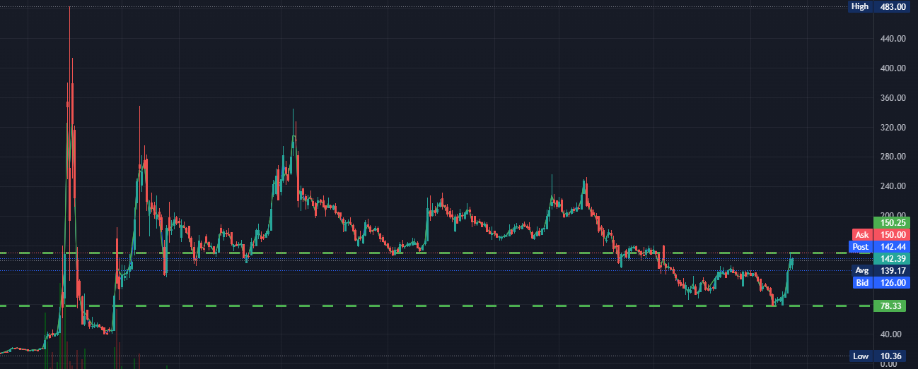

**$MSFT**

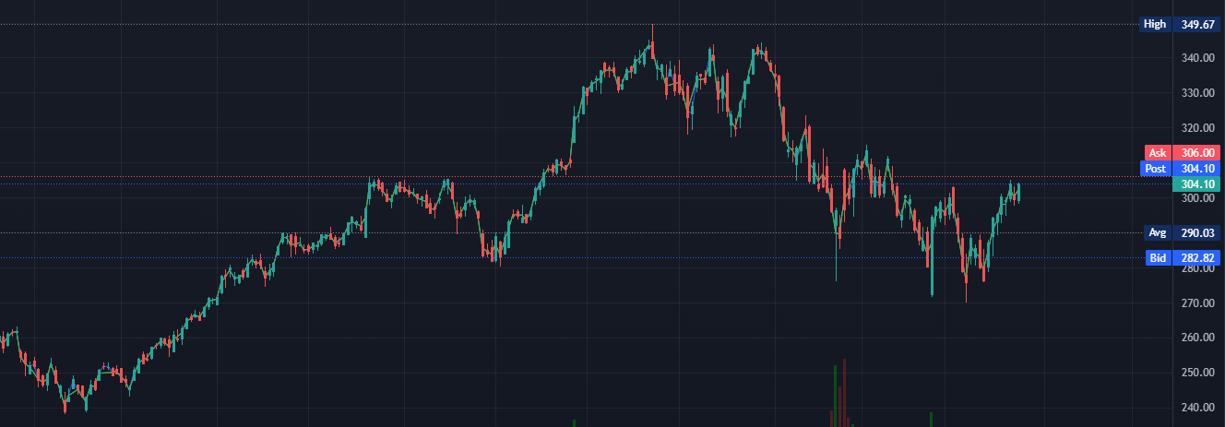

What is the distinction between these two graphs? When comparing $GME to $MSFT, it is evident that $GME has higher volatility. As a result, it has a larger volatility, which means there are more possibilities to purchase it at a low price and sell it at a higher price. There are also more points that are overbought than there are places that are oversold. MSFT On the other side, because it is so flat, there are fewer clear run-ups and hence less possibilities. As a result, you might deduce that greater volatility equals greater opportunity. Now we'll look at how to calculate volatility and how it varies over time.

**Bollinger Bands**

Are a type of band that is used to describe As a newbie, you can utilise a tool to better understand stock volatility. Bollinger bands are added to the research, as seen below. Because these Bollinger bands make the chart a little cluttered. As a beginner, though, you may add them to the chart to get a feel of volatility. Once you get more experience, you will be able to view it without these bands.

**$PTON**

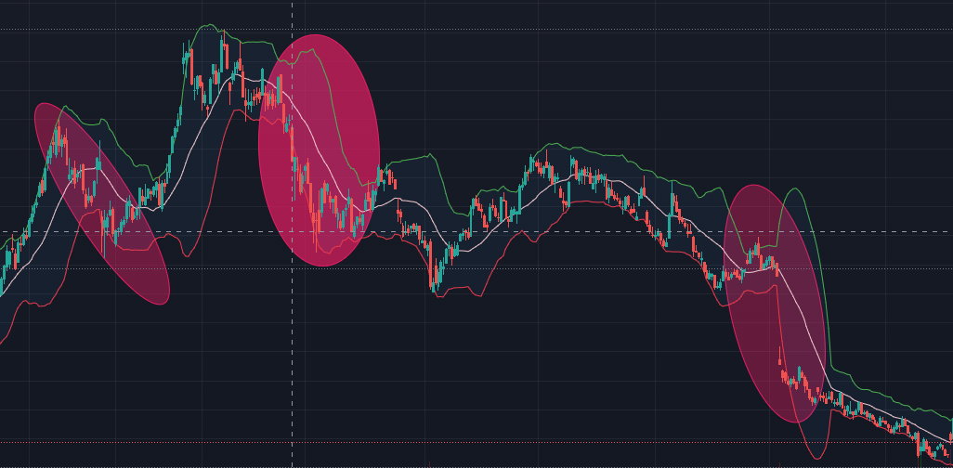

You may also deduce that this stock is more volatile during market open from this information. As a result, it may be a better time to trade this stochastic.

**Some Crucial Points**

When you have a stock that is tightening, that is, the volatility is becoming really tight. This suggests you've got a volatile squeeze on your hands. If it is opening, on the other hand, we are seeing a volatility growth. It's an elevating element to have extremely low volatility on a stock with a historical price trend of constricting and then expanding.

This occurs because it has a tendency of doing so in the past, and price action can only go to a particular tight limit. As a result, knowing when something like this is happening may be really beneficial to us.

The inverse is likewise true, in that it can only extend to a certain extent. The more Volatility is spread out, the more likely we are to see a drop in Volatility. This may be a derogatory factor.

**Important Points to Remember**

Here are a few key points to remember. More volatility is an elevating element since it might generate price action to trade. If volatility tightens/expands too much, it is more likely to shift the other direction, i.e. expand/tighten. You may use Bollinger bands to observe regions of high volatility in the beginning. You can utilise Volatility to your advantage by finding areas/time periods of high volatility. A volatility squeeze is most likely to occur just before a Breakout.

**Aggression: Finding Aggregation Periods**

Now we'll talk about aggregation periods, including what they are and how to find the right one for your aggression or conservation level. Simply explained, the aggregate period is the amount of time represented by a single candlestick. For example, you may utilise 1-minute, 2-minute, 4-hour, and a variety of other time intervals. The more forceful you are, the smaller the Time utilised for a candlestick. When trading, you should avoid being excessively aggressive or conservative. This is always dependent on the nature and duration of the employment. It's like there's a sweet spot for each position. It is only through further practise that you will be able to master it.

Example $QCOM

Let's look at $QCOM. As you can see in the image below, we have a 1-minute aggregation period, and the price movement is highly filthy, making trading difficult. This is due to the fact that we frequently discuss buying in at confirmation and selling at validation. However, because we are trading really aggressively (1 minute), we have a lot of movement on the SMA. It's not easy to swap this.

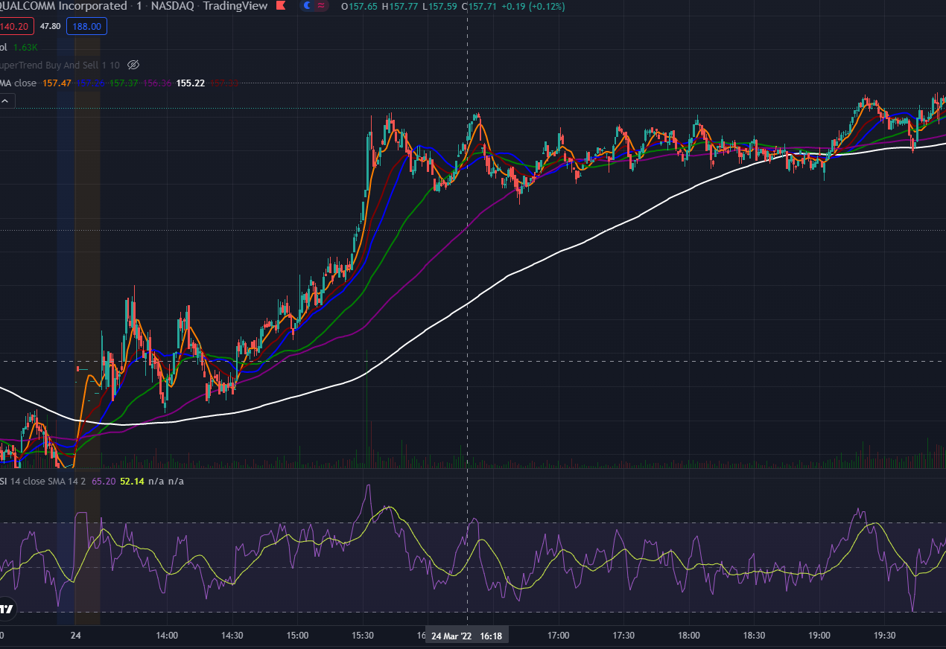

We may raise our aggregation period from 1-minute to 3-minute if we want to tidy it up a little bit. The end result may be seen below. Now that we have a clear confirmation and validation, this price movement is more tradeable.

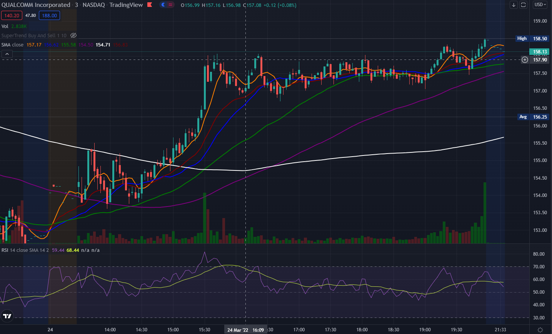

How do I know which Aggregation period I should use?

It all depends on the sort of position you're taking and the type of opportunity you're looking for. As a result, trading 3-minutes or even larger aggregate periods makes more logical. It's possible that if we increase the period too much, it'll become excessively cautious. It's still OK when we attempt 5-minutes here. It would, however, have caused you to adopt a stance a little too late. As a result, if you're too cautious, you won't be able to catch some of the moves.

**Important Points to Remember**

Here are a few key points to remember. The time depicted by 1-Candlestick on the chart represents the aggressiveness period. The shorter the aggression period, the more aggressive it is, and vice versa. A messed-up chart can be cleaned up by increasing the aggressiveness period. Your degree of aggression determines the confirmation and validation points, depending on the type and length of position you will take. It is advisable to utilise the more aggressive period for fast moving intra-day charts. If you make it too conservative, you may miss part of the price movement. You must find the sweet spot between being too aggressive and being too cautious.

**When to Exit:**

Minimize Losses and Maximize Profits We'll talk about cutting losses and taking profits in this part. We need a strategy that is both conservative and aggressive enough to safeguard our wealth while also allowing us to take winning positions. Trading, as we all know, is a probabilistic game, thus some losses are unavoidable. That is why it is critical to have a plan in place for when to accept a loss and leave a trade.

**STOP THE LOSSES**

Setting a STOP LOSS is the primary and most usual approach to limit losses.

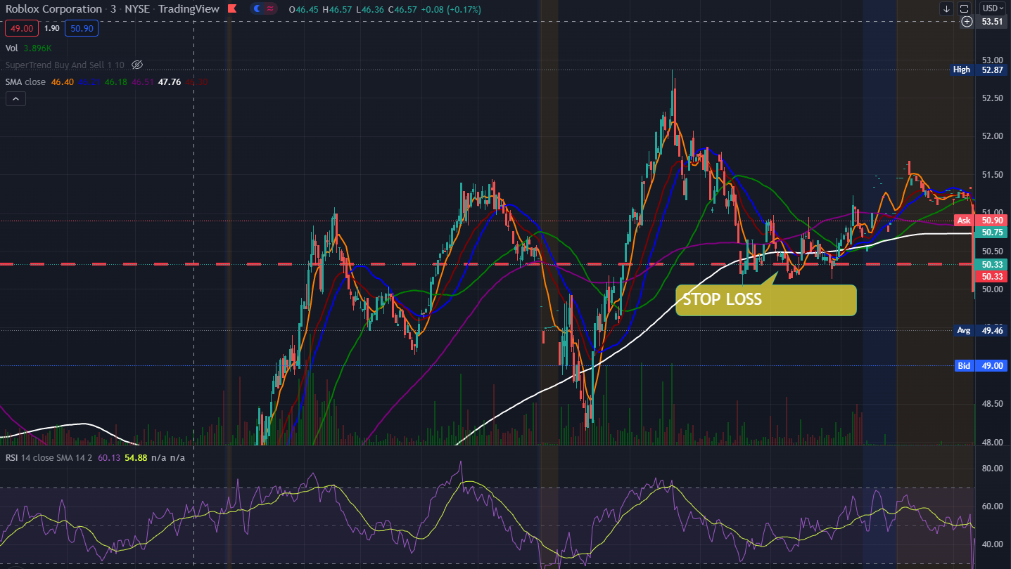

I'm not a huge supporter of utilising STOP LOSS as a catch-all technique since it's too rigid, but it's beneficial for preparing for worst-case circumstances. You shouldn't totally rely on a mechanical stop loss since it removes your intellect from the equation. If you are a newbie, it is recommended that you establish a STOP LOSS that is high enough to safeguard your money in the event of a worst-case scenario while still being low enough to be unrelated to current market movement. This is due to the fact that an overly high STOP LOSS might force you out of a trade with a minor price change.

For example, if there is a significant decline from current price action to this level, the stop loss will come in handy. The Bad Stop loss illustrated above might force you to depart a position you didn't want to leave.

**VALIDATION**

VALIDATION is the moment at which you should consider exiting a position. This has previously been mentioned in the section about SMA lines. However, this is not the entire tale. The VALIDATION POINT is not a specific departure point. It's just a moment at which you compare your elevating and depreciating aspects and make a selection.

$TTD

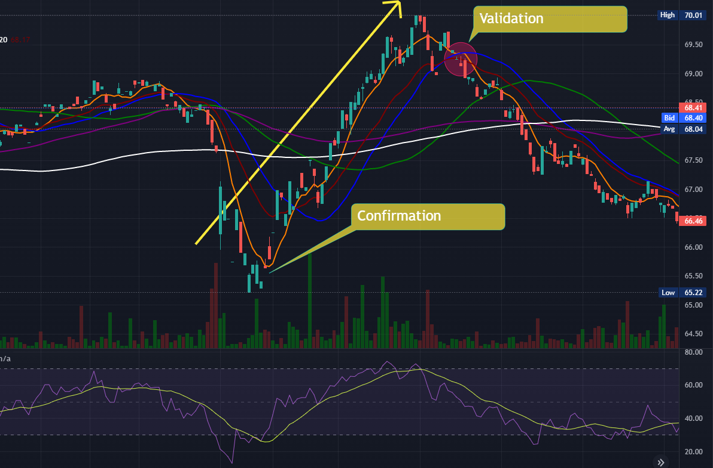

As you may be aware, we place a premium on buying a stock at CONFIRMATION. We consider VALIDATION while deciding whether to exit a trade at a profit or a loss. The first candlestick below the short-term SMA line is called VALIDATION. Simply following the CONFIRMATION and VALIDATION guidelines would have worked well in the aforementioned scenario. However, in this section, we'll talk about how to cut losses. Assume we take a position on a stock as illustrated below on CONFIRMATION, despite the fact that the RSI is overbought.

Why would you continue in it if you wouldn't contemplate taking a position at the validation point? In the example above, we can see that the RSI is now at fair value, and we are still hitting the price strength of our short-term SMA line. These are two variables that help to raise the bar. However, we are still on a downward trajectory, with an equal amount of upside and downside possibilities. As a result, it could be reasonable at this moment to limit our losses owing to these depreciating variables. This means you could lose out on the upside on the subsequent run-up, but that's alright because we can't focus on taking the entire move every time. Trading does not function like that.

If you take a loss here, you're protecting yourself against all the possible downturns. If you followed the Confirmation guidelines, you may enter a new position here and ride the price strength upward till validation. You would have been able to benefit as a result of this.

**Important Points to Remember**

Here are a few key points to remember. When deciding to quit, ask yourself, "Would I be likely to accept this job again if I wasn't currently in this position?" Because trading is a probability game, cutting losses is a necessary element of the process. If used correctly, stop losses may be beneficial. Poor stop losses might force you out of situations where you wish to stay. Charlie despises mechanical stop losses. Another option is to depart at the Validation stage. Validation refers to the moment at which there are more deprecating factors than raising factors. It is not a foreclosed exit. You must also assess the issue and take appropriate action.

**Must Perform the 7-Step Test for Profitability**

1.Find a time frame to FOCUS on.

Which time frame will you be concentrating on? Choose the one that will maintain your position for the period of your trade as well as the pattern/movement you want to trade.

2.Assess Your Risk vs. Reward Situation

Do you have a higher upward potential than you do a downward potential? Is there a sufficient "road" of reward to propel the price action higher?

3.Make a list of your elevating and depreciating factors.

Are you getting a good price on your purchases? Do you have pricing power? Are you heading in the right direction? Do you have any proof that the market is strong?

4.How does the situation appear in the long run? What are the long-term raising and depreciating factors? If you have any major long-term depreciating elements, make sure you mention them when you take a position.

5.Can you think of any news catalysts? Why am I buying and selling stocks? Is there a connection to a news catalyst? Make sure you understand that every stock market reaction is an overreaction, and that prices may reverse VERY fast.

6.What is the analyst's price target for the stock? It'll be useful to know where the analyst price target is if you're trading an investor speculative play (large run-up, news catalyst, earnings release, etc.). If it is far higher than your current trading price, this is a great motivator for sheep investors. They'll assist in raising the price.

7.Is the job VALUE FOR MONEY? Do not trade a setup that does not make sense in light of your elevating and depreciating aspects. Overtrading is a sickness that will devour your bank account like a jack rabbit devouring jack cheese.

**Smart Trading Techniques**

Developing a Plan:

A Step-by-Step Guide When trading stocks, you must have a strategy. Never get in at arbitrary entry points and then sell out when it feels like the moment is appropriate. When trading stocks, you should always have a strategy in mind. Don't make a decision based just on your feelings. You can take the emotions out of the game if you have a precise plan with entrance and exit points. What does it mean to have a strategy?

Questions to ponder

1.What must occur in order for me to be considered for a position?

a)Do I Have To Wait For Confirmation?

b)Waiting For What Elevating Factors? Is it a VALUE FOR MONEY? Is there any confirmation of the PATTERN? How strong is our price position? Is this a high-probability scenario?

Remarks

Always, always, always, always, always, always, always, always, always, always, always

1.We wait for the positive aspects to outnumber the negative factors. For that, look at price strength, fundamentals, analyst price targets, and so on.

2.How will I know when or if the stock is appropriate for my strategy?

a)Have I Activated My Alert?

b)Am I Paying Attention To The Chart?

c)Did I Make A Limit Purchase?

3.What must occur in order for me to EXIT a position?

a)Do I Have To Wait For Validation?

b)What Negative Factors Am I Anticipating? Is it now considered OVERBOUGHT? Is there a BREAK in the pattern? Is our pricing power eroding?

4.How will IFIND OUT whether or if a stock is appropriate for an exit strategy?

a)Have I Activated My Alert?

b)Am I Paying Attention To The Chart? c)Did I Make A Limit Purchase?

**Good ENTRY Plans include:**

1. "I'm noting that we're oversold, therefore I'll buy in if we have confirmation of price strength."

2."I'm observing a trend of moving from $55 to $65 on a regular basis, so if we go back to $55 and receive confirmation, I'll take a position."

3. If you're looking for a "I want to take advantage of this stock's pullback from an uptrend. But I'll hold off till I have confirmation."

**Bad ENTRYPlans Examples:**

1. "I've seen that this stock is oversold, therefore I'm going to buy because it's on sale."

2."I'm noting that we've had a tendency of moving from $55 to $65, so I'll buy in blindly when it gets close to $55"

3."This stock has had a pullback from an uptrend; I want to profit RIGHT NOW!" Because we're in a pushback, I'll simply buy in."

4.Examples of Effective Exit Strategies:

1."I'm noting that we're overbought, and we're losing price strength, so if we hit validation, I'll leave."

2."I'm going to go out since there are a lot of depreciating variables."

**EXIT Plans that dont work:**

1 "I'm going to hold and hope till the price activity improves! I'm not going to lose any money."

What are the characteristics of good plans?

a)Each one has a distinct entrance (confirmation) and exit (validation) point.

b)At each confirmation and validation step, they all require analysing various elevating and deprecating\elements. You don't purchase or sell just on the basis of confirmation and validation points.

c)They are simple and easy to understand.

**Position Timing:**

How to Calculate Position Length When it comes to how long they like to maintain employment, many people have differing perspectives (or what length positions they like to focus on). However, because the length of your position may only be predicted, you must plan ahead of time. Because the market may alter at any time, we recommend sticking to basic common sense criteria while looking for long-term holdings. Day Investing: (Buying & Selling Intraday) Rule No. 1 If the pattern, rising factors, or confirmation that you are trading-off of is on the 1day -5-day chart, your position is a DAY TRADE.

**Swing Investing:** (Buying & Selling Over Multiple Days -Weeks)

Rule #1: If the pattern, elevating variables, or confirmation that you are trading off of is on the 5-day -180 day chart, your position is an ASWING TRADE.

Trading in Positions:

(Buying & SellingOver Multiple Months -1 Year)

Rule #1: Your trade is a POSITION TRADE if the pattern, elevating elements, or confirmation you're trading off of is on the 180-day chart or above.

**Example**

**$AMZN**

On the 180-day chart, you can see that AMZN takes three weeks to shift from oversold to overbought, based on prior patterns. You're considering placing a trade after witnessing price strength confirmation on the 180-day chart. What kind of job do you think this is going to be?

Answer: If it takes three weeks on average to get from oversold to overbought, your anticipated position will take three weeks to complete. That example, you are utilising the 180-day chart but want to execute a swing trade since your forecast is three weeks.

**$MRNA**

On the same 1 minute 1 day chart, you can see that MRNA has significant intraday rising forces and is giving confirmation. What kind of job do you think this is going to be?

Answer: If these motivating variables are present on the intraday (1 minute, 1 day chart), then this is a day trade.

**How to Decide on Order Type**s

You must select an order type when making a transaction.

Here are your choices.

CURRENT Price -> Market Order -> Buy Or Sell at Buy Or Sell at SPECIFIC Price

Limit Order-> Buy Or Sell at Stop Order->Buy Or Sell at CURRENT Price

After A Specific Period Is Reached (Note: In popular culture, a "stop" order is commonly referred to as a "stop loss" order.

Order of the Market.

Examples of Market Orders 1st scenario:

If you opt to sell your shares via a market order, your shares will be sold at the next available market price. That implies that if the price is fast falling, you may be taken out at a much lower price than you desired (or at a much higher price if the price is rising).

Market orders have the best chance of being completed (and the quickest) since your shares will be executed at whatever price the market desires. The most basic type of order Market Orders have the disadvantage of being executed at a price that is drastically different from what you wanted. For example, if you wish to sell your shares for $50 at market, but the stock is rapidly declining, you can be sold out for $35. It's also true in the other direction.

Scenario 1: If you pick a limit order to sell your shares at $50, it indicates that it will only sell your shares if it is able to do so at $50. (or higher).

Scenario 2: if you set a limit and order to purchase shares at $50, it will only buy shares at $50 or less.

Limit Orders Have Advantages:

You Get What You Want.

Your execution point will not be a surprise; it will only run if it meets your order's requirements. Limit Orders Have a Few Drawbacks: Because you've provided particular criteria, if shares at your price point aren't accessible, you may never be executed. If you're trying to cut your losses in a stock that's falling fast, this may be disastrous. It might also mean missing out on opportunities to be executed into advantageous positions.

Stop Order Scenario 1: If you pick a stop order to sell your shares if it falls below $50, it will automatically create a market order to sell shares whenever it falls below that amount.

Scenario 2: if you pick a stop order to buy your shares only if it breaks over $50, it will immediately place a market order to acquire shares once it breaks above that level.

Advantages of a Stop Order:

When compared to a Limit Order, you are far more likely to be executed. This is fantastic since it means you'll be far less likely to be stuck maintaining a position if anything lowers quickly. By only executing if it passes below or over a specified threshold, this is an excellent strategy to help "guard" your money and capture breakouts.

The disadvantages of a stop order are as follows: Because a Stop Order becomes a market order once it is triggered, it is possible that you may be executed at a different price point than you intended. The notion that a "stop" order ensures downside protection is false; it just implies that it will execute you as a market order at the given level.

**The Easiest Method to Locate SWING Stocks**

In this section, we'll go through how to use the think or swim scanner to uncover some of the finest swing trade possibilities. For that, you'll need to install filters. You may accomplish this by heading to the scan tab and selecting add filter, then stock from the drop-down menu. You may add as many filters as you wish this way.

LAST, Volume, and Beta are the three filter categories most frequently employed.

Last is the most recent price at which the stock traded.

We set it to $15 instead of $1 or low since you don't want to go too low in pricing while swing trading. The motions become more irregular as you descend.

These positions are good for day trading, but they can be quite hazardous if held for more than one day (as in swing trading).

So $15 is the absolute minimum; there are possibilities lower that, but when we scan, we are searching for the finest possible setups.

We want a greater volume because we are swing trading. Values of 100,000 and above are allowed. Less volume is fine for a catalyst play where there are spikes in volume on some news, but for swing trades when you may be pulling out of a position in a week, less volume might be troublesome.

**BETA:**

Beta is the number that indicates how far a stock deviates from the market. When compared to the market, the greater the Beta, the more volatile the stock is. We like volatility for swing trades, hence a high Beta value is required.

A value of 2 is recommended as a minimum. If you want to, you can go much higher.

**Section 7:**

**Basics: What They Tell Us & How to Apply Them**

**How Do I Make ANALYST Price Targets Work For Me?**

We'll go through how to leverage analyst price targets to your advantage in this part. Many investors buy stocks solely based on the advice of their favourite analysts. We, on the other hand, do not condone such conduct. This is because relying solely on analyst price forecasts is absurd, as they are not a credible source. Many of them, in reality, are biassed and have competing interests. They do, however, serve a function for us in that they provide us a sense of how the typical individual feels about a stock's future (bearish/bullish) based on the underlying facts.

We also enjoy these analyst targets since they save us a lot of time when it comes to basic analysis. We can create a suitable target price for the future by combining the averages of numerous analysts. When you average the performance of several analyst firms, you can predict whether the firm will rise or fall in the future. This is significant because, in comparison to large analyst firms, we just do not have enough resources to look through these basics as individual traders. They engage professionals who can look into various data sets, thus they will most likely uncover more trustworthy and relevant data than we do.